25 September 2020
[135-20]

Supporting document 1

Safety assessment – Application A1192

Food derived from herbicide-tolerant corn line MON87429

Executive summary
Background

A genetically modified (GM) corn line with OECD Unique Identifier MON-87429-9, hereafter referred to as MON87429, has been developed to tolerate the following herbicides: glufosinate, dicamba, 2,4-dichlorophenoxyacetic acid (2,4-D) and aryloxyphenoxypropionate (AOPP) acetyl coenzyme A carboxylase inhibitors (known as FOPs herbicides). MON87429 has also been genetically modified to provide tissue-specific tolerance to glyphosate to facilitate hybrid seed production.

Tolerance to herbicides in MON87429 is achieved through expression of the:
- pat gene from Streptomyces viridochromogenes, which encodes a phosphinothricin-N-acetyltransferase (PAT) protein and provides tolerance to the herbicide, glufosinate
- dmo gene from Stenotrophomonas maltophilia, which encodes a dicamba mono-oxygenase (DMO) protein and provides tolerance to the herbicide, dicamba
- ft_t gene that is a modified version of the Rdpa gene from Sphingobium herbicidovorans which encodes a 2,4-D and FOPs dioxygenase protein (FT_T). This protein provides tolerance to 2,4-D and FOPs herbicides
- cp4 epsps gene from Agrobacterium sp. strain CP4, which encodes a 5-enolpyruvylshikimate-3-phosphate synthase (EPSPS) protein and provides tolerance to the herbicide, glyphosate.

The pat, dmo and cp4 epsps genes and their expressed proteins have all been assessed previously by FSANZ.

In conducting a safety assessment of food derived from MON87429, a number of criteria have been addressed including: characterisation of the transferred genes including their origin, function and stability in the corn genome; the nature of the introduced proteins and their potential to be either allergenic or toxic in humans; compositional analyses and any resultant changes in the whole food. This approach evaluates both the intended and any unintended changes in the plant.

This safety assessment addresses food safety and nutritional issues associated with the GM food. It therefore does not address:

- risks related to the environmental release of GM plants used in food production
- risks to animals that may consume feed derived from GM plants
- the safety of food derived from the non-GM (conventional) plant.

Food derived from the non-GM (conventional) plant (corn) has an accepted history of safe use and is used as the benchmark for the comparative analysis.

History of use
In terms of food production, corn is the world’s dominant cereal crop. It has a long history of safe use in the food supply, dating back thousands of years. Sweet corn is consumed directly while corn-derived products are routinely used in a large number and diverse range of foods (e.g. cornflour, starch products, breakfast cereals and high fructose corn syrup). Corn is also widely used as a livestock feed.
Molecular characterisation
The four genes transferred to corn line MON87429 (pat, dmo, ft_t and cp4 epsps) were introduced on a single expression cassette via Agrobacterium-mediated transformation. A non-protein-coding siRNA regulatory DNA sequence derived from Zea mays (corn) provides tissue-specific tolerance to glyphosate through an endogenous RNA interference pathway.

Detailed molecular analyses of corn line MON87429 indicate that a single copy of the expression cassette containing the linked pat, dmo, ft_t and cp4 epsps genes, plus their respective regulatory elements, is present at a single insertion site in the genome. There are no antibiotic resistance marker genes, nor extraneous plasmid sequences present in this line.

The introduced genetic elements and the expression of new proteins in MON87429 were shown by molecular techniques and phenotypic analyses to be stably inherited from one generation to the next and across multiple generations. The pattern of inheritance supports the conclusion that the herbicide-tolerance traits occur within a single locus in the MON87429 genome and are inherited in accordance with Mendelian principles.

Characterisation and safety assessment of new substances

Newly expressed proteins

Expression levels were generally low in all plant tissues, but particularly low in grain,which is the source of food products for human consumption. The lowest level of CP4 EPSPS was in pollen. This was expected, considering the cp4 epsps mRNA is targeted for degradation specifically in pollen, resulting in reduced protein expression in this tissue.

A range of characterisation studies confirmed the identity of the plant-expressed PAT, DMO, FT_T and CP4 EPSPS and their equivalence with the corresponding protein produced in a bacterial expression system. The plant-derived and bacterially-derived proteins all had the expected molecular weight, amino acid sequence, immunoreactivity, lack of glycosylation and enzyme activity.

Bioinformatics studies on all of the proteins were updated and confirmed the lack of any significant amino acid sequence similarity to known protein toxins or allergens. Laboratory studies demonstrated the PAT, DMO, FT_T and CP4 EPSPS proteins are susceptible to the action of digestive enzymes and would be thoroughly degraded before they could be absorbed during passage through the gastrointestinal tract. The proteins are also susceptible to heat denaturation at the high temperatures typically used in food processing. Taken together, the evidence supports the conclusion that neither PAT, DMO, FT_T nor CP4 EPSPS is toxic or allergenic in humans.

Herbicide metabolites

The herbicide metabolites generated as a result of spraying MON87429 with glufosinate, dicamba, 2,4-D and FOPs are consistent with those found in non-GM crops sprayed with these herbicides, with no novel metabolites being identified.

Compositional analyses

Detailed compositional analyses were done on grain from MON87429 and the control cultivar grown under normal agricultural conditions over 5 field-trial sites in the United States. The analyses included proximates (protein, fat, ash) amino acids, fatty acids, carbohydrates by calculation, fibre, minerals, vitamins, anti-nutrients and secondary metabolites. The levels of 68 key analytes in MON87429 were compared to those in the control and also to compositional data from a range of commercial non-GM corn varieties available from the published literature and a publicly available database.

Statistically significant differences were found between grain from MON87429 and the control for 11 of the analytes measured, however differences were small and all were within the range established for existing commercial corn varieties. Overall, the compositional data support the conclusion that there are no biologically significant differences in the levels of key constituents in grain from MON87429 compared to conventional corn varieties available on the market.

Conclusion

No potential public health and safety concerns have been identified in the assessment of herbicide-tolerant corn line MON87429. On the basis of the data provided in the present application, and other available information, food derived from MON87429 is considered to be as safe for human consumption as food derived from conventional corn varieties.

Table of contents
Executive summary i
Index of Figures 6
Index of Tables 6
List of Abbreviations 7
1 Introduction 9
2 History of use 10
2.1 Host organism 10
2.2 Donor organisms 11
2.2.1 Streptomyces viridochromogenes 11
2.2.2 Stenotrophomonas maltophilia 11
2.2.3 Sphingobium herbicidovorans 12
2.2.4 Agrobacterium sp. strain CP4 12
2.2.5 Other organisms 12
3 Molecular characterisation 13
3.1 Transformation Method 13
3.2 Detailed description of T-DNA 14
3.2.1 pat expression cassette 14
3.2.2 dmo expression cassette 15
3.2.3 ft_t expression cassette 15
3.2.4 cp4 epsps expression cassette 15
3.2.5 Other sequences 16
3.3 Development of the corn line from original transformation 17
3.4 Characterisation of the inserted DNA and site(s) of insertion 19
3.4.1 Identifying the number of integration sites 19
3.4.2 Detection of backbone sequence 19
3.4.3 Stability of the genetic changes in corn line MON87429 19
3.4.4 Insert integrity and site of integration 21
3.4.5 Open reading frame analysis 21
3.4.6 Conclusion 22
4 Characterisation and safety assessment of novel substances 23
4.1 PAT protein 23
4.1.1 Expression of PAT protein in MON87429 tissues 23
4.1.2 Characterisation of PAT protein in MON87429 and equivalence to a bacterially-produced form 24
4.1.3 Safety of the introduced PAT 26
4.1.4 Conclusion 27
4.2 DMO protein 27
4.2.1 Expression of DMO protein in MON87429 tissues 28
4.2.2 Characterisation of DMO protein in MON87429 and equivalence to a bacterially-produced form 29
4.2.3 Safety of the introduced DMO 31
4.1.4 Conclusion 32
4.3 FT_T protein 32
4.3.1 Expression of FT_T protein in MON87429 tissues 33
4.3.2 Characterisation of FT_T protein in MON87429 and equivalence to a bacterially-produced form 34
4.3.3 Safety of the introduced FT_T 36
4.3.6 Conclusion 38
4.4 CP4 EPSPS protein 38
4.4.1 Expression of CP4 EPSPS protein in MON87429 tissues 39
4.4.2 Characterisation of CP4 EPSPS protein in MON87429 and equivalence to a bacterially-produced form 41
4.4.3 Safety of the introduced CP4 EPSPS 43
4.4.3 Conclusion 44
4.5 Novel herbicide metabolites in GM herbicide-tolerant plants 44
4.5.1 Metabolism of 2,4-D 45
4.5.2 Metabolism of quizalofop-P-ethyl 45
5 Compositional analysis 46
5.1 Key Components 46
5.2 Study design 47
5.3 Analyses of key components in grain 48
5.3.1 Protein and amino acids 48
5.3.2 Total fat and fatty acids 49
5.3.3 Carbohydrates and fibre 49
5.3.4 Ash and minerals 50
5.3.5 Vitamins 50
5.3.6 Anti-nutrients and Secondary Metabolites 51
5.4 Conclusion 51
6 Nutritional impact 52
7 References 53

Index of Figures
 | Title | Page
Figure 1 | The corn wet milling process | 8
Figure 2 | Plasmid map of PV-ZMHT519224 | 11
Figure 3 | The pat expression cassette in PV-ZMHT519224 | 12
Figure 4 | The dmo expression cassette in PV-ZMHT519224 | 12
Figure 5 | The ft_t expression cassette in PV-ZMHT519224. | 12
Figure 6 | The cp4 epsps expression cassette in PV-ZMHT519224 | 13
Figure 7 | Breeding path used in the characterisation of the MON87429 corn line | 15
Figure 8 | Breeding path used to assess the inheritance and genetic stability of MON87429 | 17
Figure 9 | Tryptic Peptide Map of the MON87429-produced (A) and E. coli-produced (B) PAT proteins | 22
Figure 10 | Forms of DMO protein expressed in different GM commodities compared with wildtype DMO derived from S. maltophilia. | 25
Figure 11 | Tryptic Peptide Map of the MON87429-produced (A) and E. coli-produced (B) DMO proteins. | 27
Figure 12 | Deduced amino acid sequence of FT_T and comparison to RdpA | 29
Figure 13 | The inactivation of quizalofop and 2,4-D herbicides by the FT_T protein. | 30
Figure 14 | Tryptic Peptide Map of the MON87429-produced (A) and E. coli-produced (B) FT_T proteins. | 32
Figure 15 | Tryptic Peptide Map of the MON87429-produced (A) and E. coli-produced (B) CP4 EPSPS proteins. | 39

Index of Tables
 | Title | Page
Table 1 | The genetic elements contained in the T-DNA region of PV-ZMHT519224, used to create MON87429 | 13
Table 2 | MON87429 generations used for various analyses | 15
Table 3 | Segregation results for MON87429 in BC1, BC2 and BC3 | 18
Table 4 | Expression of PAT in MON87429 tissue samples | 21
Table 5 | Summary of considerations of PAT in previous FSANZ safety assessments | 24
Table 6 | Expression of DMO in MON87429 tissue samples | 26
Table 7 | Summary of considerations of DMO in previous FSANZ safety assessments | 29
Table 8 | Expression of FT_T in MON87429 tissue samples | 31
Table 9 | Structural stability of FT_T after exposure to 15 minutes of heat | 35
Table 10 | Structural stability of FT_T after exposure to 30 minutes of heat | 35
Table 11 | Expression of CP4 EPSPS in MON87429 tissue samples | 37
Table 12 | Expression of CP4 EPSPS in MON87429 pollen | 37
Table 13 | Summary of considerations of CP4 EPSPS in previous FSANZ safety assessments | 41
Table 14 | Comparison of protein and amino acids (% dw) | 45
Table 15 | Comparison of total fat (% dw) and fatty acids (% total fat acids) | 46
Table 16 | Comparison of carbohydrates by calculation and fibre (% dw) | 47
Table 17 | Comparison of ash and minerals | 47
Table 18 | Comparison of vitamins (mg/kg dw) | 48
Table 19 | Comparison of anti-nutrients (% dw) and secondary metabolites (µg/g dw) | 48
Table 20 | Summary of statistically significant compositional differences between control and MON87429 | 49

List of Abbreviations
2,4-D | 2,4-dichlorophenoxyacetic acid
2,4-DCP | 2,4-dichlorophenol
ADF | acid detergent fibre
αKG | alpha-ketoglutarate
AOPP | aryloxyphenoxypropionate
BLOSUM | BLOcks SUbstitution Matrix
bp | base pair
COMPARE | COMprehensive Protein Allergen REsource
CS | coding sequence
CTP | chloroplast transit peptide
DCSA | 3,6-dichlorosalicylic acid
DIMBOA | 2,4-dihydroxy-7-methoxy-2H-1,4-benzoxazin-3(4H)-one
DMO | dicamba mono-oxygenase
DNA | deoxyribonucleic acid
dw | dry weight
ECL | enhance chemiluminescence
EPSPS | 5-enolpyruvyl-3-shikimatephosphate synthase
FASTA | fast alignment search tool – all
FOPs | aryloxyphenoxypropionate group of herbicides
FSANZ | Food Standards Australia New Zealand
g | gram
GM | genetically modified
I | intron sequence
ILSI | International Life Sciences Institute
JSA | junction sequence analysis
kDa | kilodalton
LB | left border of T-DNA (Agrobacterium tumefaciens)
L | leader sequence
LOD | limit of detection
LOQ | limit of quantitation
Min | minutes
mRNA | Messenger RNA
MT | million tons
NADH | Nicotinamide Adenine Dinucleotide
NCBI | National Centre for Biotechnology Information
NDF | neutral detergent fibre
ng | nanogram
NGS | next generation sequencing
ns | not significant
OECD | Organization for Economic Co-operation and Development
OGTR | Office of the Gene Technology Regulator
ORF | open reading frame
P | promoter sequence
PAT | phosphinothricin N–Acetyltransferase
PCR | polymerase chain reaction
PPT | phosphinothricin
RB | right border of T-DNA (Agrobacterium tumefaciens)
RdpA | R-2,4-dichlorophenoxypropionate dioxygenase
RNA | ribose nucleic acid
SDS-PAGE | sodium dodecyl sulfate polyacrylamide gel electrophoresis
SE | standard error
T | terminator sequence
TDF | total dietary fibre
T-DNA | Transfer DNA
TS | targeting sequence
Ubq | ubiquitin
μg | microgram
U.S. | United States
UTR | untranslated region

1 Introduction
FSANZ received an application from Monsanto Australia Proprietary Limited to vary Schedule 26 in the Australia New Zealand Food Standards Code (the Code). The variation is to add food derived from the genetically modified (GM) herbicide-tolerant corn line MON87429 (hereafter referred to as MON87429), with the OECD Unique Identifier MON-87429-9. This line has tolerance to glufosinate, dicamba, 2,4-dichlorophenoxyacetic acid (2,4-D) and the aryloxyphenoxypropionate group of herbicides (known as FOPs). MON87429 also has tissue-specific herbicide tolerance to glyphosate.

Tolerance to herbicides containing glufosinate is achieved with the expression of the phosphinothricin-N-acetyltransferase (PAT) protein, encoded by the pat gene from the bacterium Streptomyces viridochromogenes. The PAT protein acetylates the free amino group of glufosinate to produce the herbicidally-inactive metabolite, 2-acetamido-4-methylphosphinico-butanoic acid (N-acetyl glufosinate).The PAT protein has been assessed by FSANZ in 24 previous applications and globally is represented in six major crop species and over 30 approved single GM plant events (CERA 2011).

Tolerance to herbicides containing dicamba is achieved with the expression of the dicamba mono-oxygenase (DMO) protein, encoded by the dmo gene from the bacterium Stenotrophomonas maltophilia. The DMO protein rapidly demethylates dicamba to the herbicidally-inactive metabolite 3,6-dichlorosalicylic acid (DCSA). The DMO protein has been assessed by FSANZ in 3 previous Applications: A1118 – corn line MON87419 (FSANZ 2016), A1080 – cotton line MON88701 (FSANZ 2014a) and A1063 – soybean line MON87708 (FSANZ 2012a).

Tolerance to 2,4-D and FOPs herbicides is achieved with the expression of the FT_T protein, encoded by a modified version of the R-2,4-dichlorophenoxypropionate dioxygenase
(Rdpa) gene from the bacterium Sphingobium herbicidovorans. The FT_T protein catalyses a dioxygenase reaction to metabolise the FOP herbicide quizalofop into the herbicidally-inactive metabolite quizalofop phenol. Through a similar reaction, the FT_T protein also results in the degradation of 2,4-D into herbicidally-inactive metabolite 2,4-dichlorophenol (2,4-DCP). FSANZ has previously assessed applications that include GM plant events which provide tolerance to 2,4-D (A1094, A1073, A1046, A1042) and FOPs (A1042). However, FT_T or the RdpA protein has not been previously assessed by FSANZ.

Tolerance to herbicides containing glyphosate is achieved through expression of the CP4 5-enolpyruvyl-3-shikimatephosphate synthase (EPSPS) protein, encoded by the cp4 epsps gene from the common soil bacterium Agrobacterium sp strain CP4. The CP4 EPSPS protein is able to function in the presence of the herbicide glyphosate, as opposed to the homologous protein naturally occurring in all plants, including corn. Tissue-specific glyphosate susceptibility is achieved through an endogenous male tissue-specific regulatory element. MON87429 plants sprayed with glyphosate during tassel development are tolerant to glyphosate but produce non-viable pollen. The CP4 EPSPS protein has previously been assessed by FSANZ in 15 previous applications and in a range of crops including corn. Additionally, tissue-specific expression of CP4 EPSPS has been previously assessed in A1066 – corn line MON87427 (FSANZ 2012b). However, the mechanism of tissue-specific expression differs.

The Applicant has indicated that MON87429 will be combined with other approved corn lines, including glyphosate-tolerant lines, using traditional plant breeding methods. The rationale for combining multiple herbicide tolerance traits is to improve control of a greater variety of weeds, provide flexibility to use different combinations of herbicides, minimise or delay the development of herbicide resistance in weedy species, and improve crop yield with the use of herbicides supported by evidence-based safety records.

Corn line MON87429 will be grown in North America and approval for cultivation in Australia or New Zealand is not being sought. If approved, food derived from this line may enter the Australian and New Zealand food supply as imported food products. A commercial trade name for MON87429 had not been determined at the time of submission.

2 History of use

2.1 Host organism
Corn (Zea mays) is also referred to as maize and has been cultivated for human consumption and other uses for thousands of years (Ranum et al., 2014). It has been studied extensively due to its economic importance in many industrialised countries of the world.

Mature corn plants consist of both female and male flowers and usually reproduce sexually by wind-pollination. This provides for both self-pollination and natural out-crossing between plants, both of which are agronomically undesirable, since the random nature of the crossing leads to lower yields (CFIA 1994). The commercial production of corn now utilises controlled cross-pollination of two inbred lines (using conventional techniques) to combine desired genetic traits. The resulting hybrid varieties are known to be superior to open-pollinated varieties in terms of their consistently higher yields and other performance characteristics.

This inbred-hybrid concept and resulting yield response is the basis of the modern corn seed industry and hybrid corn varieties are used in most developed countries for consistency of performance and production.

In terms of production, corn is the world’s dominant cereal crop (2018/19 = 1,125 MT) ahead of wheat (731 MT) and rice (499 MT) (USDA 2019). Corn is grown worldwide, with the United States and China being the largest producers in 2018/19 (366 and 257 MT, respectively). Corn is not a major crop in Australia or New Zealand and in 2017, production was approximately 0.436 and 0.176 MT, respectively (FAOSTAT 2017). In the U.S. it is estimated that ~92% of all corn planted is GM while in Canada, the estimate of GM corn is ~80% of total corn. No GM corn is currently grown commercially in Australia or New Zealand.

Limited domestic production is supplemented by importing corn grain and corn-based products that are used widely in processed foods. Imports to Australia and New Zealand included 9,593 and 2,194 tonnes respectively of corn flour and 2,038 and 553 tonnes respectively of corn oil (FAOSTAT 2017). Corn is a major source of crystalline fructose and high fructose corn syrup, both of which are processed from corn starch. About 3,000 tonnes of crystalline fructose, but negligible high fructose corn syrup, were imported into Australia in 2011 (Green Pool 2012); neither Australia nor New Zealand currently produce fructose (either crystalline or as high fructose corn syrup).

Dent corn is the predominant corn type grown in the U.S. and is most commonly grown for grain and silage (OGTR 2008). The non-GM parent line LH244 used to produce MON87429 is a patented hybrid corn line assigned to Holden’s Foundation Seeds LLC in 2001 (Armstrong 2001). It is a medium season yellow dent corn line that is adapted to the central regions of the U.S. corn-belt.

Dent corn is processed by one of two main production methods (White and Pollak 1995):

- Dry milling gives rise to food by-products such as corn meal, flour and hominy grits.
- Wet milling (see Figure 1), which involves steeping the grain, coarse and fine grinding, centrifugation and evaporating the steep, to yield food by-products such as starch (for corn starch, corn syrup and individual sweeteners such as dextrose and fructose) and germ (for oil) (CRA 2006).
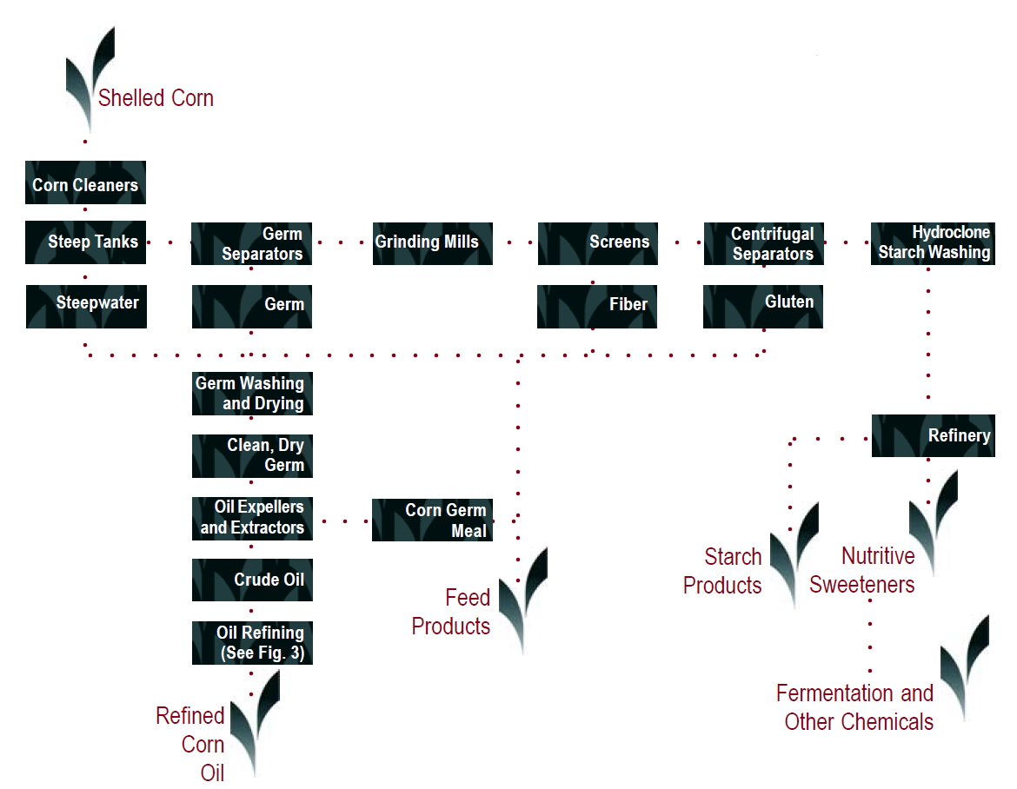
Figure 1: The corn wet milling process [diagram from CRA (2006)]

2.2 Donor organisms

2.2.1 Streptomyces viridochromogenes
The source of the pat gene is the bacterium species Streptomyces viridochromogenes. Streptomycetae bacteria were first described in the early 1900’s and are widespread in the environment. These organisms are generally soil-borne, although they may also be isolated from water. They are not typically pathogenic to animals including humans and few species have been shown to be phytopathogenic (Kützner, 1981).

The bar gene from the closely related species S. hygroscopicus produces a protein that is structurally and functionally equivalent to the protein encoded by the pat gene (Wehrmann et al., 1996). Although S. viridochromogenes and S. hygroscopicus are not used in the food industry directly, the pat and bar genes have been used to confer tolerance to glufosinate ammonium herbicides in food producing crops for over two decades.

2.2.2 Stenotrophomonas maltophilia
The dmo gene is derived from the bacterium Stenotrophomonas maltophilia strain DI-6, isolated from soil at a dicamba manufacturing plant (Krueger et al., 1989). This bacterium has been assessed as a donor organism previously under Applications A1118: food derived from corn line MON87419, A1063: food derived from soybean line MON87708 and A1080: food derived from cotton line MON88701. The organism was originally named Pseudomonas maltophilia, but was subsequently re-classified to Xanthomonas maltophilia, before it was given its own genus (Palleroni and Bradbury, 1993).
S. maltophilia is an aerobic, gram negative bacterium commonly present in aquatic environments and soil. It is also commonly associated with plants (Ryan et al., 2009) and has been isolated from the rhizosphere of wheat, maize, grasses, beet, cucumber, potato, strawberry, sugarcane and rapeseed, and has also been isolated from cottonseed, bean pods and coffee. S. maltophilia is widespread in moist sites in domestic houses, particularly in bathrooms and kitchens, as well as a variety of foods such as fruits, vegetables, frozen fish, milk and poultry (Denton et al., 1998).

Infections in humans caused by S. maltophilia are rare; it is found in healthy individuals without any adverse associations. Although not regarded as virulent, S. maltophilia can be an opportunistic pathogen when conditions are more favourable, for example in immuno-compromised hospital patients (Looney, 2009), particularly those with ventilator tubes or catheters inserted for prolonged periods of time. However, as the dmo gene has been manipulated through standard DNA cloning methods subsequent to its isolation, extraneous material from S. maltophilia would not be carried across to MON87429. Additionally, S. maltophilia has a history of safe use as a donor organism for the dmo gene.

2.2.3 Sphingobium herbicidovorans
The ft_t gene is a modified version of the Rdpa gene sourced from the common soil bacterium Sphingobium herbicidovorans. This bacterium has been assessed as a donor organism previously under Application A1042: food derived from corn line DAS-40278-9.

The Sphingobium genus is part of a larger group of bacteria called Sphingomonads, which are commonly found in nature (Chaudhardy et al., 2017), including associated with food products such as corn (Rijavec et al., 2007), rice (Videira et al., 2010), papaya (Thomas et al., 2007), tomato (Enya et al., 2007) and fermented milk (Bauer et al., 2009), among others. Members of the Sphingobium genus are also commonly used in the food industry (Fialho et al., 2008; Pozo et al., 2007) and in bioremediation (Jin et al., 2013; Alarcón et al., 2008).

S. herbicidovorans is a strictly aerobic, gram-negative, non-sporulating, yellow-pigmented bacterium that can utilise phenoxy auxin and AOPP herbicides as carbon sources (Takeuchi et al., 2001; Zipper et al., 1996). It is not known to be associated with human disease.

2.2.4 Agrobacterium sp. strain CP4
The source of the cp4 epsps gene is the common soil bacterium Agrobacterium sp. strain CP4. This bacterium has been assessed by FSANZ as a donor organism in 15 previous GM applications in a range of crops including canola, corn, cotton, lucerne, potato, soybean and sugerbeet.

Agrobacterium species are known soil-borne plant pathogens but are not pathogenic to humans or other animals.

2.2.5 Other organisms
Genetic elements from several other organisms have been used in the genetic modification of MON87429 (refer to Table 1). These genetic elements are non-coding sequences and are used to regulate the expression of the new genes.

3 Molecular characterisation
Molecular characterisation is necessary to provide an understanding of the genetic material introduced into the host genome and helps to frame the subsequent parts of the safety assessment. The molecular characterisation addresses three main aspects:

- the transformation method together with a detailed description of the DNA sequences introduced to the host genome
- a characterisation of the inserted DNA, including any rearrangements that may have occurred as a consequence of the transformation
- the genetic stability of the inserted DNA and any accompanying expressed traits.

The Applicant has submitted the following unpublished studies for the molecular characterisation of MON87429.
Unpublished studies
- Molecular Characterization of Herbicide Tolerant Maize (MON87429) (2018). Report MSL0030619. Monsanto Company.
- Bioinformatics Evaluation of the Transfer DNA Insert in MON87429 Utilizing the AD_2018, TOX_2018, and PRT_2018 Databases (2018). Report MSL0029454. Monsanto Company.
- Bioinformatics Evaluation of the DNA Sequences Flanking the 5ʹ and 3ʹ Junctions of the MON87429 Insert: Assessment of Putative Peptides (2018). Report MSL0029453. Monsanto Company.
- Segregation Analysis of the T-DNA Insert in Herbicide Tolerant Maize MON87429 Across Three Generations (2018). Report MSL0029841. Monsanto Company.
- Demonstration of the Presence of CP4 EPSPS, DMO, PAT and FT_T Proteins in Maize Grain Samples across Multiple Generations of MON87429 (2019). Report MSL0030646. Monsanto Company.

3.1 Transformation Method
In order to create MON87429, plasmid PV-ZMHT519224 was transformed into the corn variety LH244. Plasmid PV-ZMHT519224 contains one T-DNA insert that encodes PAT, DMO, FT_T and CP4 EPSPS (Figure 2).

The transformation method involved infection of immature embryos excised from a post-pollinated corn ear with the disarmed Agrobacterium strain ABI containing the PV-ZMHT519224 plasmid (Sidorov and Duncan, 2009). Immature embryos were then placed on selective media containing glyphosate and carbenicillin. The glyphosate enables selection of transformants, while the carbenicillin suppresses the growth of excess Agrobacterium. Once the transformed embryos developed into calluses, the calluses were placed on media to encourage shoot and root development. Rooted plants (R0) with normal phenotypes were transferred to soil and allowed to self-pollinate and produce R1 seed. PCR screening and Southern blot analysis was then used to identify seeds carrying only the T-DNA region, allowing selection of plants that would not contain the antibiotic resistance gene located on the vector backbone.

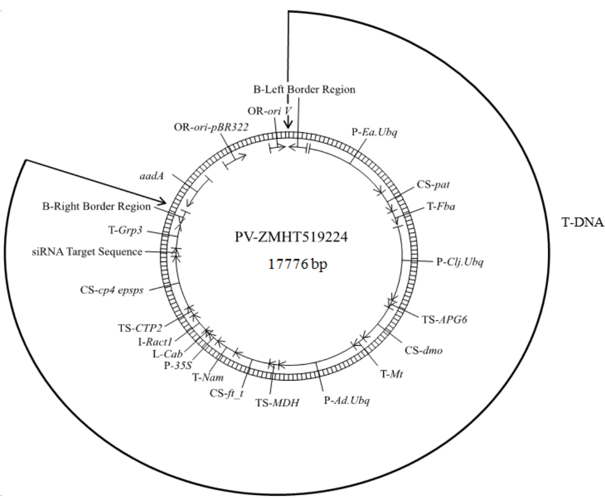
Figure 2: Plasmid map of PV-ZMHT519224. The T-DNA contains the pat, dmo, ft_t and cp4 epsps expression cassettes. The vector backbone contains two origins of replication (ori pBR322, ori V) and the aadA selectable marker gene. The vector backbone is not incorporated into the plant but is required for preparing the plasmid, passaging through standard laboratory Escherichia coli (E. coli) and into the Agrobacterium.

3.2 Detailed description of T-DNA
The plasmid PV-ZMHT519224 (Figure 2), used to generate MON87429, contains four expression cassettes in the T-DNA region.

3.2.1 pat expression cassette
At the left border (LB) is the pat expression cassette (Figure 3). Expression of pat is under the control of the promoter (P), 5’ untranslated region (UTR) and intron sequences of the ubiquitin (Ubq) gene from Erianthus ravennae (plume grass) and the terminator (T) sequence of the fructose-bisphosphate aldolase (Fba) gene from Setaria italica (foxtail millet).

The protein coding sequence (CS) for the pat expression cassette encodes a single polypeptide of 183 amino acids. Co-translational processing of the PAT protein in MON87429 results in the removal of the N-terminal methionine, a process that normally occurs in eukaryotes (Wingfield 2017).
Figure 3: The pat expression cassette in PV-ZMHT519224.

3.2.2 dmo expression cassette
The dmo expression cassette follows the pat expression cassette in the T-DNA region (Figure 4). Expression of dmo is under the control of the promoter, 5’UTR and intron sequences of the Ubq gene from Coix lacryma-jobi (adlay millet), the chloroplast-targeting sequence (TS) of the Albino and pale green 6 (APG6) gene from Arabidopsis thaliana (thale cress) and the terminator sequence from the OsMt gene from Oryza sativa (rice).

The protein CS for the dmo expression cassette encodes a polypeptide of 408 amino acids. The first 68 amino acids represents the chloroplast transit peptide (CTP) and the remaining 340 amino acids represents the DMO protein. Alternative processing of the CTP results in two forms of the mature DMO protein. One form consists of 340 amino acids encoded by the dmo gene and the other form is 341 amino acids that includes an additional cysteine at the N-terminus that is derived from the APG6 gene. Following the cleavage of CTP, it is rapidly degraded.
Figure 4: The dmo expression cassette in PV-ZMHT519224.

3.2.3 ft_t expression cassette
The ft_t expression cassette follows the dmo expression cassette in the T-DNA region (Figure 5). Expression of ft_t is under the control of the promoter, 5’UTR and intron sequences of the Ubq gene from Arundo donax (giant reed), the chloroplast-TS of the malate dehydrogenase (Mdh) gene from Arabidopsis thaliana and the terminator sequence from the no apical meristem (Nam) gene from Oryza sativa.

The protein CS for the ft_t expression cassette encodes a polypeptide of 376 amino acids. The first 81 amino acids represents the CTP and the remaining 295 amino acids represents the FT_T protein. Processing of the CTP results in a single 296 amino acid FT_T protein that consists of 295 amino acids encoded by the ft_t gene and an additional alanine at the N-terminus that is derived from the Mdh gene. The FT_T protein is a modified version of the RdaA protein from S. herbicidovorans, with a sequence similarity of ~89%.
Figure 5: The ft_t expression cassette in PV-ZMHT519224.

3.2.4 cp4 epsps expression cassette
The cp4 epsps expression cassette follows the ft_t expression cassette in the T-DNA region (Figure 6). Expression of cp4 epsps is under the control of the promoter and leader (L) sequence of the 35S RNA from cauliflower mosaic virus (CaMV), the 5’UTR of the chlorophyll a/b-binding (CAB) protein from Triticum aestivum (wheat) and intron (I) and flanking UTR sequence of the actin 1 (act1) gene from Oryza sativa. A chloroplast-TS of the ShkG gene from Arabidopsis thaliana, CTP2, directs the transport of the CP4 EPSPS protein to chloroplasts. A partially modified 3’UTR sequence from Zea mays (corn) supresses cp4 epsps gene expression in corn male tissue as it contains a target sequence that is recognised by endogenous male tissue-specific siRNA. At the right border (RB) the cp4 epsps expression cassette also contains the terminator sequence of the glycine-rich RNA-binding protein (Grp3) gene from Oryza sativa.

The protein coding sequence for the cp4 epsps expression cassette encodes a polypeptide of 531 amino acids. The first 76 amino acids represents CTP2 and the remaining 455 amino acids represents the CP4 EPSPS protein. While it is similar and functionally equivalent to endogenous plant EPSPS proteins, CP4 EPSPS has reduced affinity for glyphosate.
Figure 6: The cp4 epsps expression cassette in PV-ZMHT519224.

3.2.5 Other sequences
There are intervening sequences present in the T-DNA region as outlined in Table 1. These sequences assist with cloning, mapping and sequence analysis.

Table 1: The genetic elements contained in the T-DNA region of PV-ZMHT519224, used to create MON87429.
Genetic element | Relative position | Source | Description, Function & Reference
LB region | 1-442 | Agrobacterium tumefaciens | LB sequence used to transfer the T-DNA region to the host (Barker et al., 1983)
Intervening sequence | 443-513 | Synthetic
pat expression cassette
P-Ea.Ubq | 514-2695 | Erianthus ravennae | Promoter, 5’UTR and intron sequences of the Ubq gene that directs transcription in plant cells (Cornejo et al., 1993)
Intervening sequence | 2696-2700 | Synthetic
CS-pat | 2701-3252 | Streptomyces viridochromogenes | Coding sequence of the PAT protein that provides tolerance to glufosinate (Wohlleben et al., 1988; Wehrmann et al., 1996)
T-Fba | 3253-3629 | Setaria italica | 3´UTR of the Fba gene containing the termination sequence (Hunt, 1994)
Intervening sequence | 3630-3691 | Synthetic
dmo expression cassette
P-Clj.Ubq | 3692-5617 | Coix  lacryma-jobi | Promoter, 5’ UTR and intron sequences of the Ubq gene that directs transcription in plant cells (Cornejo et al., 1993)
Intervening sequence | 5618-5627 | Synthetic
TS-APG6 | 5628-5831 | Arabidopsis thaliana | Coding sequence of an optimized transit peptide derived from the APG6 gene that directs protein to the chloroplasts
CS-dmo | 5832-6854 | Stenotrophomonas maltophilia | Optimised coding sequence of the DMO protein that provides tolerance to dicamba (Herman et al., 2005; Wang et al., 1997)
Intervening sequence | 6855-6862 | Synthetic
T-Mt | 6863-7162 | Oryza sativa | 3´UTR of the OsMt gene containing the termination sequence (Hunt, 1994)
Intervening sequence | 7163-7170 | Synthetic
Ft_t expression cassette
P-Ad.Ubq | 7171-9127 | Arundo donax | Promoter, 5’UTR and intron sequences of the Ubq gene that directs transcription in plant cells (Cornejo et al., 1993)
Intervening sequence | 9128-9140 | Synthetic
TS-MDH | 9141-9383 | Arabidopsis thaliana | Coding sequence of a transit peptide from Mdh gene that directs protein to the chloroplasts
CS-ft_t | 9384-10271 | Sphingobium  herbicidovorans | Coding sequence if the modified RdpA protein that provides tolerance to 2,4-D and FOPs (Müller et al., 2006)
Intervening sequence | 10272-10286 | Synthetic
T-Nam | 10287-10803 | Oryza sativa | 3´UTR of the Nam gene containing the termination sequence (Hunt, 1994)
Intervening sequence | 10804-10809 | Synthetic
Cp4 epsps expression cassette
P-35S | 10810-11133 | Cauliflower mosaic virus | Promoter and leader sequence of 35S RNA that directs transcription in plant cells (Odell et al., 1985)
Intervening sequence | 11134-11155 | Synthetic
L-Cab | 11156-11216 | Triticum aestivum | 5’UTR of the Cab gene that directs transcription in plant cells (Lamppa et al., 1985)
Intervening sequence | 11217-11232 | Synthetic
I-Ract1 | 11233-11712 | Oryza sativa | Intron and flanking UTR sequence of the actin 1 gene that is involved in gene expression regulation (McElroy et al., 1990)
Intervening sequence | 11713-11721 | Synthetic
TS-CTP2 | 11722-11949 | Arabidopsis thaliana | Coding sequence of a transit peptide from the ShkG gene that directs the EPSPS protein to the chloroplasts (Herrmann, 1995; Klee et al., 1987)
CS-cp4 epsps | 11950-13317 | Agrobacterium sp.  strain CP4 | Optimised coding sequence of the aroA gene for the CP4 EPSPS protein that provides tolerance to glyphosate (Barry et al., 2001)
Intervening sequence | 13318-13323 | Synthetic
siRNA target sequence | 13324-13524 | Zea mays | Modified partial 3’UTR sequence that targets cp4 epsps mRNA in male tissue for siRNA mediated degradation (Yang et al., 2018).
Intervening sequence | 13525-13532 | Synthetic
T-Grp3 | 13533-14143 | Oryza sativa | 3´UTR of the Grp3 gene containing the termination sequence (Hunt, 1994)
Intervening sequence | 14144-14184 | Synthetic
RB region | 14185-14515 | Agrobacterium tumefaciens | Right border sequence used to transfer the T-DNA region to the host (Depicker et al., 1982; Zambryski et al., 1982)

3.3 Development of the corn line from original transformation
A breeding pedigree for the various generations used in the characterisation of MON87429 and to obtain the commercial varieties is given in Figure 7.

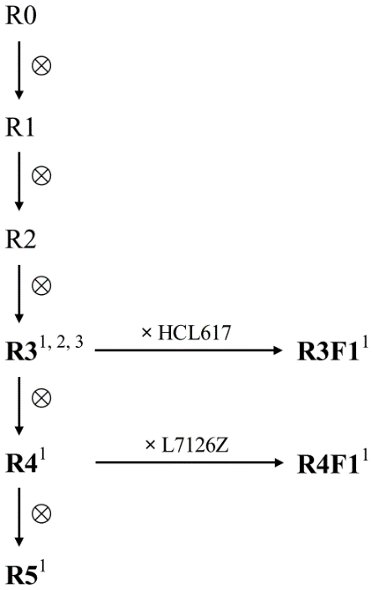
designates self-pollination
¹ generations used to confirm insert stability
² generation used for molecular characterisation
³ generation used for breeding commercial
varieties containing the MON87429 event.
⊗
Figure 7: Breeding path used in the characterisation of the MON87429 corn line. R0 corresponds to the transformed plant, where PV-ZMHT519224 was introduced into LH244. The R1 plant used to propagate the subsequent generations was identified by PCR to contain only the T-DNA sequences. At the R3 and R4 generations, plants were crossed with conventional proprietary hybrid lines and the progeny were used to generate information on insert stability. Bolded text represents generations used in subsequent analyses.

From a single R0 plant, several rounds of self-pollination and seed bulking occurred in order to produce specific generations of plants that were used in characterisation and analysis, as indicated in Table 2.

Table 2: MON87429 generations used for various analyses

Analysis | MON87429 generation used | Control(s) used
Molecular characterisation (Section 3.4) | R3 (LH244) | LH244
Genetic stability (Section 3.4.3.1) | R3 (LH244)  R3F1 (LH244 x HCL617)  R4 (LH244)  R4F1 (LH244 x L7126Z)  R5 (LH244) | LH244  LH244 x HCL617  LH244 x L7126Z
Mendelian inheritance (Section 3.4.3.2) | BC1 (LH244 x T9108Z)  BC2 (LH244 x T9108Z)  BC3 (LH244 x T9108Z)  (see Figure 7) | N/A
Expression of phenotype over several generations  (Section 3.4.3.2) | R3 (LH244)  R3F1 (LH244 x HCL617)  R4 (LH244)  R4F1 (LH244 x L7126Z)  R5 (LH244) | LH244
Protein expression levels in plant parts (Section 4.1.1, 4.2.1, 4.3.1 & 4.4.1) | R3F1 (LH244 x HCL617) | N/A
Protein characterisation (Section 4.1.2, 4.2.2, 4.3.2 & 4.4.2) | Plant-produced proteins were compared to E. coli-produced proteins used for safety studies; plants used were R3F1 (LH244 x HCL617) | Proteins from E. coli
Compositional analysis (Section 5) | R3F1 (LH244 x HCL617) | LH244 x HCL617

3.4 Characterisation of the inserted DNA and site(s) of insertion
A range of analyses were undertaken to characterise the genetic modification in MON87429. These analyses focused on the nature and stability of the insertion and whether any unintended re-arrangements or products may have occurred as a consequence of the transformation procedure. When characterising MON87429, different generations of plants were analysed and these are outlined in Table 2.

3.4.1 Identifying the number of integration sites
Next-generation sequencing (NGS) was performed on seed-derived genomic DNA from MON87429 (R3) and the parental LH244 cultivar. A reference sequence was generated using plasmid PV-ZMHT519224 and the parental DNA spiked with PV-ZMHT519224. After preparation of a paired-end library using ~500 bp lengths of sheared genomic DNA, the samples were sequenced using Illumina NextSeq technology. Sufficient sequence fragments were obtained to cover the entire genomes of MON87429 and LH244, with a depth of coverage ≥75x. Comparison of the sequence between MON87429 and LH244 showed that a single integration event has occurred, with only two junction sites detected.

3.4.2 Detection of backbone sequence
NGS of the seed-derived DNA from MON87429 (R3) and the parental LH244 cultivar resulted in zero reads that mapped to the backbone sequences: aadA, OR-ori-pBR322 or OR-ori V (see Figure 2). Read mapping aligned the siRNA target sequence in the parental LH244 cultivar and the PV-ZMHT519224 plasmid. This is expected, since the siRNA target sequence is derived from the corn genome.

3.4.3 Stability of the genetic changes in corn line MON87429
The concept of stability encompasses both the genetic and phenotypic stability of the introduced trait over a number of generations. Genetic stability refers to maintenance of the modification (as produced in the initial transformation event) over successive generations. It is best assessed by molecular techniques, such as Southern blot analysis or NGS/junction sequence analysis (JSA). Phenotypic stability refers to the expressed trait remaining unchanged over successive generations. It is often quantified by a trait inheritance analysis to determine Mendelian heritability via assay techniques (chemical, molecular, visual).

3.4.3.1 Genetic stability
NGS was used to show inheritance and genetic stability of the inserted T-DNA in MON87429. Sequences of seed-derived DNA from five generations of MON87429 (R3, R3F1, R4, R4F1, R5) were mapped to the PV-ZMHT519224 plasmid for junction identification. Control genomic DNA was isolated from the non-GM parental line LH244 and conventional hybrid lines (LH244 × HCL617 and LH244 × L7126Z) with similar background genetics to the R3F1 and R4F1 hybrids.

No junction sequences were detected in DNA obtained from the control lines (LH244, LH244 × HCL617 and LH244 × L7126Z). Molecular analysis of the MON87429 DNA from all generations showed the presence of the same two junction sequences as described in Section 3.4.1. No other junction sequences were present. The consistency of the JSA results across all generations tested demonstrates that the single T-DNA insert is stably maintained in MON87429.

3.4.3.2 Phenotypic stability
Mendelian inheritance

Since the T-DNA insert resides at a single locus within the MON87429 genome, the genetic material within it would be expected to be inherited according to Mendelian principles.

Chi-square (Χ²) analysis was also undertaken over several generations (as outlined in Figure 8) to confirm the segregation and stability of the T-DNA insert in MON87429.

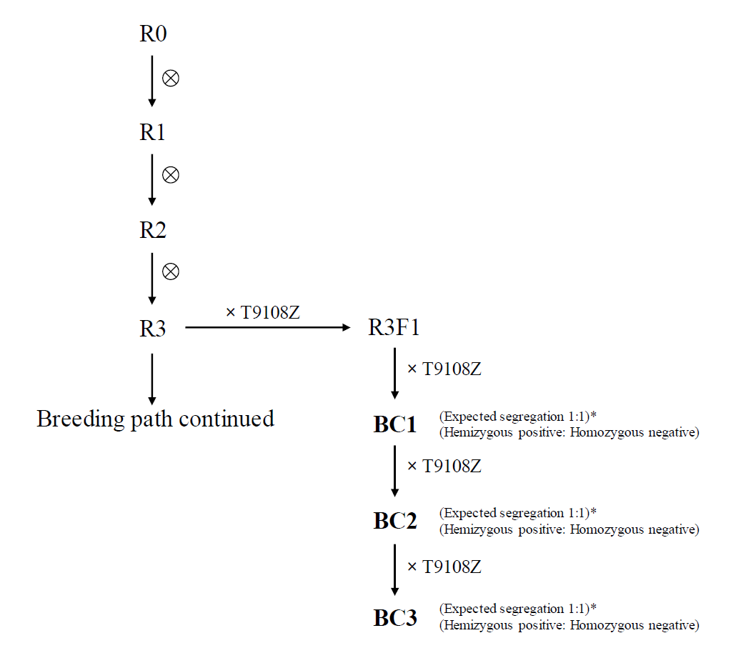
designates self-pollination
* generations whose segregation data
was used in the Χ² analysis.
⊗
Figure 8: Breeding path used to assess the inheritance and genetic stability of MON87429. R3 MON87429 was crossed with a null proprietary inbreed parental variety (T9108Z) to produce a R3F1 hemizygous seed. Crossing R3F1 plants with T9108Z is expected to produce 1:1 hemizygous positive: homozygous negative progeny. Continual crossing of hemizygous progeny with T9108Z is expected to result in the same ratios.

The inheritance pattern was assessed in BC1, BC2 and BC3 generations by an endpoint PCR assay, using PCR primers targeting the T-DNA region introduced into MON87429. According to Mendelian inheritance principles, the expected segregation ratio of 1:1 was observed at BC1, BC2 and BC3 generations (Table 3). These data support the conclusion that the T-DNA is present at a single locus in MON87429 and was inherited predictably according to Mendelian principles in subsequent generations.

Table 3: Segregation results for MON87429 in BC1, BC2 and BC3
 | BC1 |  | BC2 |  | BC3
 | Observed | Expected | Observed | Expected | Observed | Expected
Positive | 48% | 50% | 47% | 50% | 45% | 50%
Negative | 52% | 50% | 53% | 50% | 55% | 50%
X² | 0.55 |  | 0.61 |  | 2.24
P | ns* |  | ns |  | ns
*ns – not significant

Expression of phenotype over several generations

The Applicant also examined expression stability of PAT, DMO, FT_T and CP4 EPSPS proteins over five generations. Western blot analysis was conducted on seed tissue from generations R3, R3F1, R4, R4F1 and R5 of MON87429 (Figure 7). LH244 was used as the negative control and E. Coli-produced PAT, DMO, FT_T and CP4 EPSPS proteins (see Section 4.1.2, 4.2.2, 4.3.2 and 4.4.2) were used as positive controls. All proteins migrated similarly to the positive controls and were present in all five breeding generations. These data support the conclusion that the PAT, DMO, FT_T and CP4 EPSPS proteins are stably expressed over several generations.

3.4.4 Insert integrity and site of integration
PCR and DNA sequence analysis of seed-derived DNA from MON87429 showed that a single copy of the DNA was integrated into the host genome and the organisation of the insert is as expected. No deletions, insertions, mutations or rearrangements of the inserted DNA were detected when the MON87429 sequence was aligned with the T-DNA of the plasmid sequence. There was some truncation of the left and right border regions of the inserted T-DNA but this would not affect the expression of the pat, dmo, ft_t and cp4 epsps genes. These results were fully consistent with the NGS dataset.

PCR and DNA sequencing of LH244 genomic DNA and the 5’ and 3’ insert-to-flank DNA junctions of the MON87429 insert identified the site of integration. By comparing the LH224 and MON87429 sequences the analysis indicated a small 54 base deletion of corn genomic DNA during T-DNA integration. Additionally, the MON87429 5’ and 3’ flanking sequence had a 29 base and 31 base insertion, respectively. Changes such as these are common during plant transformation (Anderson et al., 2016) and would not affect the expression of the pat, dmo, ft_t and cp4 epsps genes.

3.4.5 Open reading frame analysis
The inserted DNA and junction regions were analysed for putative open reading frames (ORFs) coding for polypeptides of 8 or more amino acids.

A total of 20 open reading frames were identified, representing 6 putative polypeptides from the insert and 14 putative polypeptides from the junctions. The amino acid sequences corresponding to these ORFs were analysed for potential allergenicity and toxicity using an in silico approach. These analyses are theoretical only as there is no reason to expect that any of the identified ORFs would, in fact, be expressed.

3.4.5.1 Bioinformatic analysis for potential allergenicity
The Applicant has provided the results of in silico analyses comparing the 20 putative polypeptides to known allergenic proteins listed in the COMprehensive Protein Allergen Resource (COMPARE) database, from the Health and Environmental Science Institute. At the date of the search, there were 2,038 sequences in the allergen database.

Three types of analyses were performed for this comparison:

(a) Full length sequence search – a FASTA alignment was performed comparing the whole sequence to the database entries. Significant homology was determined when there was more than 50% similarity between the query protein and database entry (BLOSUM50), with the E-value threshold set at 1 x 10⁻⁵ (1e-5).

(b) 80-mer sliding window search – a FASTA alignment was performed comparing all contiguous 80 amino acids within the ORF to the database entries. Matches were identified if there was greater than 35% homology.

(c) 8-mer exact match search – A FASTA alignment was performed comparing contiguous 8 amino acids within the ORF to the database entries. Matches were identified if there was 100% homology.

No matches of significance or concern were identified.

3.4.5.2 Bioinformatic analysis for potential toxicity
The Applicant provided results from in silico analyses comparing the 20 putative polypeptides to known protein toxins identified in the NCBI protein database. At the date of the search, there were 28,344 sequences in this database. A FASTA algorithm was used with a BLOSUM50 scoring matrix and the E-value threshold conservatively set to 1 x 10⁻⁵ (1e-5). Of the 20 putative peptides identified, only one putative peptide had greater than 80 contiguous amino acids and 35% homology to known toxins belonging to the GNAT (GCN5-related N-acetyltransferase) family toxin-antitoxin system of bacteria. The homology spanned a region of the T-DNA insert corresponding to the coding region and reading frame of the pat gene.

Bacterial toxin-antitoxin systems are widespread and only toxic when produced intracellularly in bacteria (Makarova et al., 2009). The GNAT family of proteins are acetyltransferases (as is PAT) and alignments with these proteins does not indicate that the PAT protein would be toxic in humans. This is in line with previously published safety assessments of the PAT protein (Hérouet et al., 2005).

No other matches were found to any known protein toxins.

3.4.6 Conclusion
The data provided by the Applicant showed that a single integration event has occurred at a specific locus. The complete T-DNA region from PV-ZMHT519224, containing the pat, dmo, ft_t and cp4 epsps expression cassettes, has been inserted, without rearrangement, deletions or insertions. Furthermore, no backbone sequences from the transforming plasmid were present, including antibiotic resistance genes. The introduced DNA was shown to be stably inherited from one generation to the next. No new ORFs are created by the insertion that raise potential toxicity or allergenicity concerns.

4 Characterisation and safety assessment of novel substances
In considering the safety of novel proteins it is important to consider that a large and diverse range of proteins are ingested as part of the normal human diet without any adverse effects.
Only a small number of dietary proteins have the potential to impair health, because they have anti-nutrient properties or they can cause allergies in some consumers (Delaney et al., 2008). As proteins perform a wide variety of functions, different possible effects have to be considered during the safety assessment including potential toxic, anti-nutrient or allergenic effects.

To effectively identify any potential hazards, knowledge of the characteristics, concentration and localisation of all newly expressed proteins in the organism as well as a detailed understanding of their biochemical function and phenotypic effects is required. It is also important to determine if the newly expressed protein is expressed in the plant as expected, including whether any post-translational modifications have occurred.

4.1 PAT protein
The wildtype PAT protein encoded by the pat gene from S. viridochromogenes consists of 183 amino acids and shares 85% amino acid identity with the PAT protein encoded by the bar gene from S. hygroscopicus. Although they exhibit 29 amino acid differences, these PAT proteins are regarded as equivalent; both exhibiting a high degree of enzyme specificity, recognising and detoxifying only one substrate phosphinothricin (PPT) (Wehrmann et al 1996).

PPT is the active constituent of glufosinate ammonium herbicides. PPT inhibits the endogenous plant enzyme, glutamine synthetase, an enzyme involved in amino acid biosynthesis in plant cells. By inhibiting glutamine synthetase, PPT causes rapid accumulation of ammonia in the plant cell, leading to plant death. In glufosinate-tolerant GM plants, the introduced PAT enzyme chemically inactivates PPT by acetylation of the free ammonia group to produce N-acetyl glufosinate, thus allowing plants to continue amino acid biosynthesis in the presence of the herbicide.

The PAT protein in MON87429 is identical to that produced in the source organism S. viridochromogenes except that the N-terminal methionine has been removed co-translationally. This results in a protein comprised of 182 amino acids with an apparent molecular weight of ~25.5 kilodalton (kDa).

4.1.1 Expression of PAT protein in MON87429 tissues
Unpublished study
- Assessment of DMO, PAT (pat), FT_T and CP4 EPSPS Protein Levels in Maize Tissues Collected from MON87429 Produced in United States Field Trials During 2017 (2019). Report MSL0030257. Monsanto Company.

Protein expression in plant tissues was determined by a validated multiplexed immunoassay study. An analytical reference standard for plant-derived PAT was generated using bacterially-expressed PAT protein, of which the characterisation is described in Section 4.1.2.

In order to determine the sites of accumulation of the protein, samples were collected from MON87429 grown in the presence of glufosinate, dicamba, 2,4-D and quizalofop from five field-trial sites in the USA. For each tissue sample analysed, four samples were processed from each field-trial site. Specific tissues were collected at different growth stages.

The results from the protein analysis (Table 4) showed the highest expression of PAT was in the leaf. This was demonstrated in leaf material collected at the leaf development (2-4) stage. The lowest expression was seen in the grain.

Table 4: Expression of PAT in MON87429 tissue samples
Tissue | Growth Stage | PAT (μg/g dw)³
 |  | Mean¹ | SE² | Range
Forage | R5 | 1.3 | 0.067 | 0.71-1.8
Grain | R6 | 0.84 | 0.066 | 0.32-1.5
Leaf | V2-V4 | 5.8 | 0.4 | 2.9-9.8
Root | V2-V4 | 2.0 | 0.15 | 0.4-3.1
1. Data was generated from a pooled sample of tissue for each tissue type, across all sites (n=20). 2. SE = standard error. 3. dw = dry weight.

4.1.2 Characterisation of PAT protein in MON87429 and equivalence to a bacterially-produced form
Unpublished study
- Characterization of the PAT Protein Purified from the Maize Grain of MON87429 and Comparison of the Physicochemical and Functional Properties of the Plant-Produced and Escherichia coli (E. coli)-Produced PAT Proteins (2018). Report MSL0029659. Monsanto Company.

The equivalence of the MON87429- and E. coli-produced PAT proteins must be established before the safety data generated using E. coli-produced PAT can be applied to MON87429-produced PAT protein.

The plant-produced PAT protein was purified from ground grain of MON87429 by chromatography and the E. coli-produced PAT protein was generated following the fermentation of E. coli containing a plasmid that expresses the protein.

In order to confirm the identity and equivalence for the MON87429- and E. coli-produced PAT proteins, a series of analytical techniques were employed:

4.1.2.1 Molecular weight analysis
Aliquots of purified MON87429- and E. coli-produced PAT proteins were run on SDS-PAGE then visualised with Brilliant Blue G-Colloidal stain. The MON87429- and E. coli-produced PAT were shown to be pure and have an apparent molecular weight of 25.5 and 24.8 kDa, respectively. These molecular weights are within acceptance limits for equivalence.

4.1.2.2 N-terminal sequencing
N-terminal sequencing confirmed that the first 15 amino acids of MON87429- and E. coli-produced PAT proteins were as expected, although the N-terminal methionine residue of MON87429-produced PAT protein was missing, likely due to cleavage. This sequence information confirms the identity of the MON87429-produced PAT protein.

4.1.2.3 Peptide mass fingerprint analysis
Peptide mapping showed that the protein being expressed in MON87429 and E. coli was PAT, with 100% and 86% sequence coverage achieved, respectively (Figure 9).
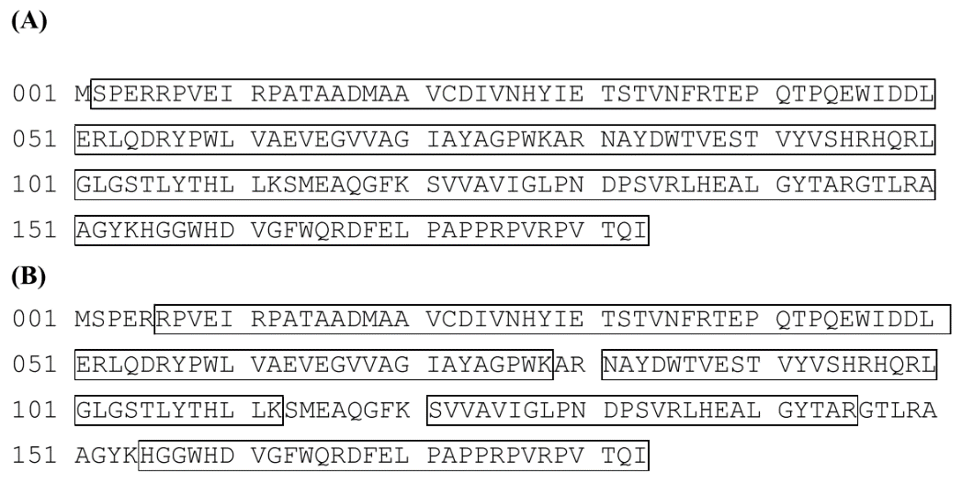
Figure 9: Tryptic Peptide Map of the MON87429-produced (A) and E. coli-produced (B) PAT proteins. The deduced amino acid sequence is 183 amino acids as shown. Boxed regions correspond to peptide sequence coverage achieved using Nano LC-MS/MS.

4.1.2.4 Western blot and immunoreactivity analysis
Western blot analysis with a PAT-specific antibody showed that the protein being expressed in MON87429 and E. coli were PAT proteins and they have equivalent immunoreactivity.

4.1.2.5 Glycosylation analysis
An enhanced chemiluminescence (ECL) detection procedure showed the PAT protein from both MON87429 and E. coli was equivalent and that neither is glycosylated.

4.1.2.6 Functional activity analysis
A coenzyme A release assay that assesses protein-specific activity showed that MON87429- and E. coli-produced PAT proteins had equivalent functional activity.

4.1.2.7 Conclusion
The data demonstrated that the bacterially-produced PAT protein is suitable as a:
- positive control for the Western blot experiment used to characterise the phenotypic stability of PAT in Section 3.4.3.2
- standard for the immunoassay study used to detect PAT protein in plant tissues as discussed in Section 4.1.1
- surrogate for use in the safety assessment experiments described in Section 4.1.3.

4.1.3 Safety of the introduced PAT
Unpublished studies
Bioinformatics study
- Bioinformatics Evaluation of the PAT Protein Utilizing the AD_2018, TOX_2018, and PRT_2018 Databases (2018). Report RAR-2018-0231. Monsanto Company.
Digestibility study
- Assessment of the in vitro Digestibility of Phosphinothricin N-Acetyltransferase Protein by Pepsin and Pancreatin (2019). Report MSL0030203. Monsanto Company.
Thermolability study
- Effect of Heat Treatment on the Functional Activity of Escherichia coli-Produced Phosphinothricin N-acetyltransferase Protein (2019). Report SCR-2019-0110. Monsanto Company.
Acute toxicity study
- PAT/pat Protein Acute Toxicity by Oral Gavage in Mice (2014). Report SA13205*. Bayer CropScience.

The PAT protein, encoded by either the pat or bar genes (Hérouet et al., 2005; Wehrmann et al., 1996), has now been considered in 24 FSANZ safety assessments (A372, A375, A380, A385, A386, A446, A481, A518, A533, A543, A589, A1028, A1040, A1046, A1073, A1080, A1081, A1087, A1094, A1106, A1112, A1116, A1118 and A1140). These assessments, together with the published literature, firmly establish the safety of PAT and confirm that it does not raise toxicity or food allergenicity concerns in humans (Hammond et al., 2011; Delaney et al., 2008; Hérouet et al., 2005).

Relevant FSANZ Applications are listed in Table 5 and the detailed safety assessment reports are available on the FSANZ website. The Applicant has submitted further studies with this application (listed above). The bioinformatics study that looks for amino acid sequence similarity to known protein toxins and allergens in publicly available databases, were updated and the results do not alter conclusions reached in previous assessments. The Applicant also provided in vitro digestibility (pepsin and pancreatin) and thermolability studies for the PAT protein that confirmed conclusions from previous Applications as listed in Table 5. The digestibility studies indicate the PAT protein would be rapidly degraded in the stomach following ingestion and thermolability studies show the protein is inactivated by heating.

Table 5: Summary of considerations of PAT in previous FSANZ safety assessments

Consideration | Sub-Section | PAT
Potential toxicity | Amino acid sequence similarity to protein toxins | This application – using search updated in 2018
 | In vitro digestibility | A1080 (FSANZ 2014a)
 | Acute oral toxicity | A385 (FSANZ 2001)
Potential allergenicity | Source of the protein | A1081 (FSANZ 2014b)
 | Amino acid sequence similarity to allergens | This application – using search updated in 2018
 | Stability to heat | A1080 (FSANZ 2014a)

4.1.4 Conclusion
A range of characterisation studies were performed on plant-derived PAT confirming its identity and functionality as well as equivalence to the corresponding protein produced in a bacterial expression system. Expression of PAT in MON87429 was highest in leaf tissue and lowest in grain. Bioinformatic analyses showed PAT had minimal amino acid sequence similarity to known toxins and allergens. The protein was shown to be heat labile and susceptible to pepsin and pancreatin digestion. Taken together this indicates that the PAT protein is unlikely to be toxic or allergenic to humans.

4.2 DMO protein
Tolerance to dicamba in MON87429 is conferred by the expression of DMO. Wildtype DMO was initially purified from the S. maltophilia strain DI-6, which was isolated from soil at a dicamba manufacturing plant (Krueger et al., 1989).

DMO is a mono-oxygenase enzyme that catalyses the demethylation of dicamba (3,6-dichloro-2-methoxy benzoic acid) to a non-herbicidal compound DCSA and formaldehyde. The active form of the enzyme is a trimer of DMO monomers. This trimeric quaternary structure is the native form of the enzyme observed during crystallisation and is an absolute requirement for electron transfer (oxidation of Nicotinamide Adenine Dinucleotide [NADH]) and catalysis.

The newly expressed DMO protein is active in the chloroplast. To target the protein to the organelle, an additional coding sequence (APG6 derived from A. thaliana, Table 1) was included in the gene construct to enable translation of a precursor DMO protein with a CTP of 68 amino acids at the N-terminus. Although leader (transit) peptides are typically clipped precisely from the precursor protein as uptake occurs, in some cases there is alternative processing resulting in forms of the protein with parts of the transit peptide remaining at the N-terminus.

Alternative processing of the precursor DMO protein has occurred in MON87429, giving rise to two forms of the enzyme. One form has retained 1 cysteine amino acid from APG6 and is known as DMO+1; the other form, known as DMO+0, does not contain any amino acids from APG6. The difference between these two forms is 1 amino acid of the transit peptide at the N-terminus of the precursor DMO protein. Except for the additional amino acid derived from APG6 and an additional leucine at position two, the mature DMO protein in MON87429 has the same sequence as the wildtype DMO protein from the DI-6 strain of S. maltophilia (Herman et al., 2005). The analyses in Section 4.2 relate to both forms of the enzyme in MON87429, which are collectively referred to as DMO protein.

Alternatively-processed DMO proteins have been assessed previously in Applications A1118 (MON87419 corn), A1080 (MON88701 cotton) and A1063 (MON87708 soybean). A comparison of the alternatively-processed DMO proteins in the different plant lines with the wildtype bacterial DMO protein is presented in Figure 10. As indicated, in some forms of the enzyme, including those in MON87429, the N-terminal methionine has also been retained. The differences between the wildtype and MON87429 DMO proteins were not expected to result in changes in overall structure, immunoreactivity, enzyme activity or substrate specificity. The N-terminus and position two are sterically distant from the catalytic site of the enzyme (D’Ordine et al., 2009; Dumitru et al., 2009).

The dmo gene prepared by the Applicant encodes a protein of 408 amino acids, consisting of a 68 amino acid CTP and a 340 and 341 amino acid DMO protein. After cleavage of the CTP, the mature protein has an apparent molecular weight of 38.4 kDa.

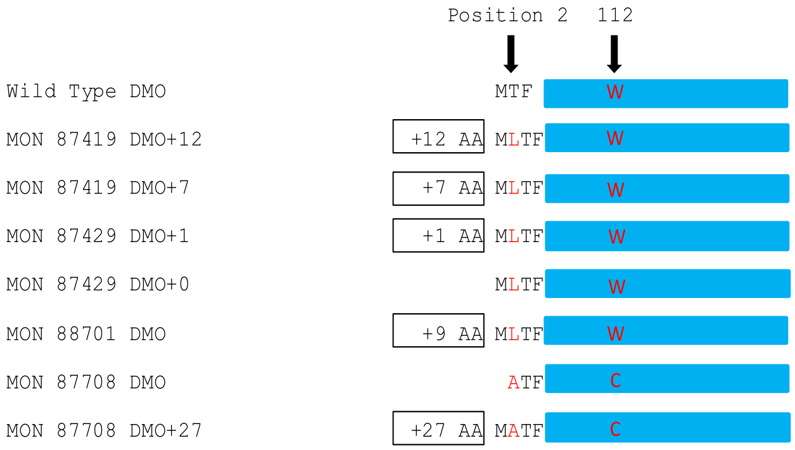
Figure 10: Forms of DMO protein expressed in different GM commodities compared with wildtype DMO derived from S. maltophilia. Boxed text shows additional amino acids (AA) from transit peptides. Red text refers to AA differences. Blue regions indicate areas of 100% amino acid identity.

4.2.1 Expression of DMO protein in MON87429 tissues
Unpublished study
- Assessment of DMO, PAT (pat), FT_T and CP4 EPSPS Protein Levels in Maize Tissues Collected from MON87429 Produced in United States Field Trials During 2017 (2019). Report MSL0030257. Monsanto Company.

DMO expression in plant tissues was determined in the same multiplexed immunoassay study as described in Section 4.1.1. The analytical reference standard for plant-derived DMO, however, was generated using bacterially-expressed DMO, of which the characterisation is described in Section 4.2.2.

The results from the protein analysis (Table 6) showed the highest expression of DMO was in the leaf. This was demonstrated in leaf material collected at the leaf development (2-4) stage. The lowest expression was seen in the root.

Table 6: Expression of DMO in MON87429 tissue samples
Tissue | Growth Stage | DMO (μg/g dw)³
 |  | Mean¹ | SE² | Range
Forage | R5 | 21 | 1.6 | 9.1-32
Grain | R6 | 2.4 | 0.15 | 1.3-3.6
Leaf | V2-V4 | 35 | 2.3 | 16-55
Root | V2-V4 | 2.3 | 0.27 | 1.0-5.2
1. Data was generated from a pooled sample of tissue for each tissue type, across all sites (n=20). 2. SE = standard error. 3. dw = dry weight.

4.2.2 Characterisation of DMO protein in MON87429 and equivalence to a bacterially-produced form
Unpublished study
- Characterization of the Dicamba Mono-Oxygenase Protein Purified from the Maize Grain of MON87429 and Comparison of the Physicochemical and Functional Properties of the Plant-Produced and Escherichia coli (E. coli)-Produced Dicamba Mono-Oxygenase Proteins (2018). Report MSL0029510. Monsanto Company

The equivalence of the MON87429- and E. coli-produced DMO proteins must be established before the safety data generated using E. coli-produced DMO can be applied to MON87429-produced DMO protein.

The plant-produced DMO protein was purified from ground grain of MON87429 by chromatography and the E. coli-produced DMO protein was generated following the fermentation of E. coli containing a plasmid that expresses the protein. Both the plant-produced DMO protein and the E. coli-produced DMO protein were a mixture of the DMO+0 and DMO+1 proteins. DMO+0 and DMO+1 proteins are collectively referred to as DMO protein.

In order to confirm the identity and equivalence for the MON87429- and E. coli-produced DMO proteins, a series of analytical techniques were employed:

4.2.2.1 Molecular weight analysis
Aliquots of purified MON87429- and E. coli-produced DMO proteins were run on SDS-PAGE then visualised with Brilliant Blue G-Colloidal stain. The two forms of DMO protein co-migrate on SDS-PAGE since the difference between them is a single amino acid. The MON87429- and E. coli-produced DMO were shown to be pure and have an apparent molecular weight of 38.4 and 38.0 kDa, respectively. These molecular weights are within acceptance limits for equivalence.

4.2.2.2 N-terminal sequencing
N-terminal sequencing confirmed that the first 15 amino acids of MON87429- and E. coli-produced DMO proteins were as expected. Both the DMO protein beginning with the CTP derived cysteine (DMO+1) and the methionine (DMO+0) were observed. This sequence information confirms the identity of the MON87429-produced DMO protein.

4.2.2.3 Peptide mass fingerprint analysis
Peptide mapping showed that the protein being expressed in MON87429 and E. coli was DMO, with 86% and 100% sequence coverage achieved, respectively (Figure 11).
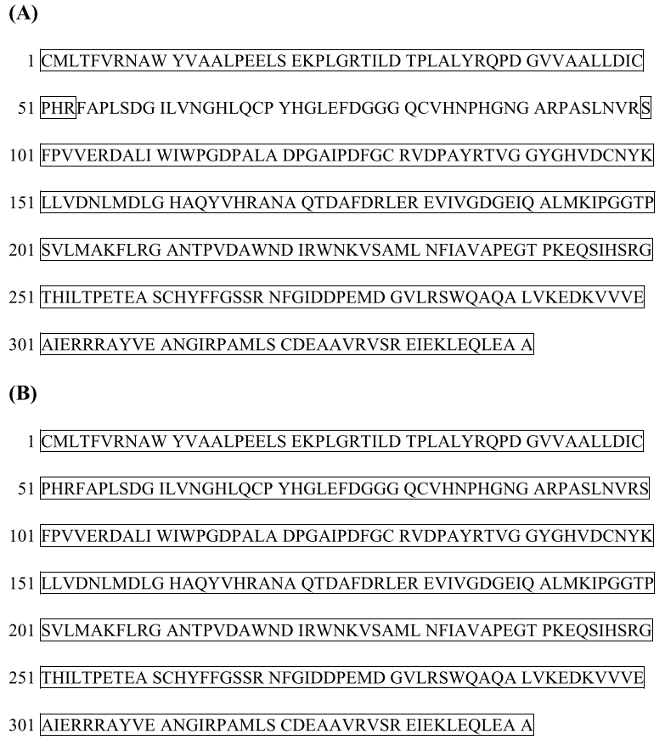
Figure 11: Tryptic Peptide Map of the MON87429-produced (A) and E. coli-produced (B) DMO proteins. The deduced amino acid sequence is 341 amino acids as shown. Boxed regions correspond to peptide sequence coverage achieved using Nano LC-MS/MS.

4.2.2.4 Western blot and immunoreactivity analysis
Western blot analysis with a DMO-specific antibody showed that the protein being expressed in MON87429 and E. coli was DMO and they have equivalent immunoreactivity.

4.2.2.5 Glycosylation analysis
An ECL detection procedure showed the DMO protein from both MON87429 and E. coli was equivalent and that neither is glycosylated.

4.2.2.6 Functional activity analysis
A high-performance liquid chromatography and fluorescent detection assay that measures the amount of dicamba that was converted to DCSA showed that MON87429- and E. coli-produced DMO protein had equivalent functional activity.

4.2.2.7 Conclusion
These data demonstrated that the bacterially-produced DMO protein is a suitable:
- positive control for the Western blot experiment used to characterise the phenotypic stability of DMO in Section 3.4.3.2
- standard for the immunoassay study used to detect DMO protein in plant tissues as discussed in Section 4.2.1
- surrogate for use in the safety assessment experiments described in Section 4.2.3.

4.2.3 Safety of the introduced DMO
Unpublished studies
Bioinformatics study
- Bioinformatics Evaluation of the DMO and FT_T Proteins in MON87429 Utilizing the AD_2018, TOX_2018, and PRT_2018 Databases (2018). Report MSL0029452. Monsanto Company.
Digestibility study
- Assessment of the in vitro Digestibility of Escherichia coli-produced Dicamba Mono-oxygenase Protein by Pepsin and Pancreatin (2018). Report MSL0029822. Monsanto Company.
Thermolability study
- The Effect of Heat Treatment on the Functional Activity of Escherichia coli (E. coli)-produced MON87429 DMO Protein (2018). Report MSL0029818. Monsanto Company.
Acute toxicity study
- An Acute Oral Gavage Toxicity Study of MON87429 DMO Protein in CD-1 Mice (2018). Report MSL0029551. Monsanto Company.

The DMO protein has been considered in 3 previous FSANZ safety assessments. It was initially considered in A1063 – soybean line MON87708 (FSANZ, 2012a), then again in A1080 – cotton line MON88701 (FSANZ, 2014a) and finally in A1118 – corn line MON87419 (FSANZ, 2016). Results in the published literature also support the safety of DMO (EFSA 2011; Delaney et al., 2008; Behrens et al., 2007; Chakraborty et al., 2005; Duke 2005; Schmidt & Shaw 2001).

Relevant FSANZ Applications are listed in Table 7 and the detailed safety assessment reports are available on the FSANZ website. The Applicant has submitted further studies with this application (listed above). The bioinformatics study that looks for amino acid sequence similarity to known protein toxins and allergens in publicly available databases, were updated and the results do not alter conclusions reached in previous assessments. The Applicant also provided in vitro digestibility (pepsin and pancreatin) and thermolability studies for the DMO protein that confirmed conclusions from previous Applications as listed in Table 7. The digestibility studies indicate the DMO protein would be rapidly degraded in the stomach following ingestion and thermolability studies show the protein is inactivated by heating.

Table 7: Summary of considerations of DMO in previous FSANZ safety assessments

Consideration | Sub-Section | PAT
Potential toxicity | Amino acid sequence similarity to protein toxins | This application – using search updated in 2018
 | In vitro digestibility | A1080 (FSANZ 2014a)
 | Acute oral toxicity | A1063 (FSANZ 2012a)
Potential allergenicity | Source of the protein | A1063 (FSANZ 2012a)
 | Amino acid sequence similarity to allergens | This application – using search updated in 2018
 | Stability to heat | A1080 (FSANZ 2014a)

4.2.4 Conclusion
A range of characterisation studies were performed on plant-derived DMO protein confirming its identity and functionality as well as equivalence to the corresponding protein produced in a bacterial expression system. Expression of DMO in MON87429 was highest in leaf tissue and lowest in the root. Bioinformatic analyses showed DMO had no amino acid sequence similarity to known toxins and allergens. The protein was shown to be heat labile and susceptible to pepsin and pancreatin digestion. Taken together this indicates that the DMO protein is unlikely to be toxic or allergenic to humans.

4.3 FT_T protein
FT_T is a modified version of the wildtype RdpA enzyme and as described in Section 2.2.3, RdpA is not derived from a bacterial source associated with human disease. RdpA belongs to a diverse superfamily of Fe(II)/alpha-ketoglutarate dependent hydroxylases that catalyse a range of oxygenation reactions (Müller et al., 2006; Hausinger et al., 2004). This protein superfamily is present throughout the plant, animal and bacterial kingdoms (Kundu, 2012; Hausinger et al., 2004) and is therefore present in a wide range of foods consumed by humans.

The FT_T protein shares ~89% sequence identity with the wildtype RdpA protein (Figure 12). The substitution of 30 amino acids has resulted in an FT_T protein that has improved enzyme kinetics and substrate affinity for 2,4-D compared to the RdpA protein. These changes to the protein sequence do not alter the specificity of the FT_T protein for its substrate. Humans have been exposed to many different members of the Fe(II)/alpha-ketoglutarate dependent hydroxylase superfamily, each with their own protein sequence but similarities in structure, without adverse effects.

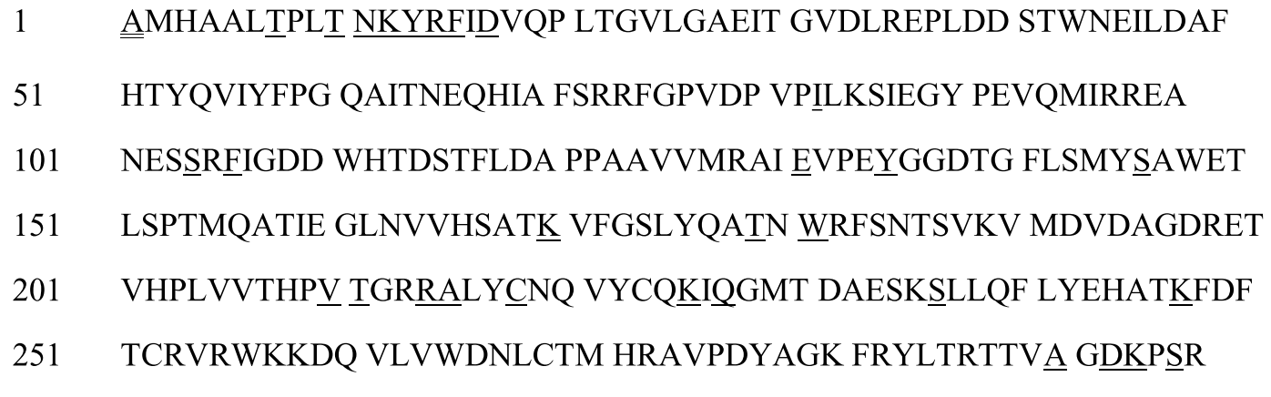
Figure 12: Deduced amino acid sequence of FT_T and comparison to RdpA. Double underline represents the alanine amino acid from the CTP and single underline shows the 30 amino acid substitutions relative to the RdpaA protein.

Due to the structural similarity between FT_T and RdpA, FT_T is also an alpha-ketoglutarate-dependent non-heme iron dioxygenase. In the presence of alpha-ketoglutarate (αKG) and oxygen, FT_T metabolises the FOP herbicide quizalofop into the herbicidally-inactive metabolite quizalofop phenol and pyruvate (Figure 13). Similarly in the presence of αKG and oxygen, FT_T also metabolises the synthetic auxin herbicide 2,4-D into the herbicidally-inactive metabolite 2,4-dichlorophenol (2,4-DCP) and glyoxylic acid (Figure 13).
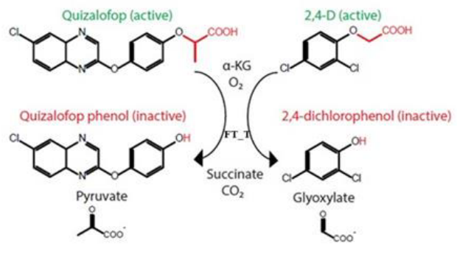
Figure 13: The inactivation of quizalofop and 2,4-D herbicides by the FT_T protein.

Alternative cleavage of the precursor FT_T protein has occurred in MON87429 (see Section 3.2.3). The alanine amino acid from the Mdh gene remains on the N-terminus. Incomplete processing of the CTP in plants is common (Richter & Lamppa, 1988).

The ft_t gene prepared by the Applicant encodes a protein of 376 amino acids, consisting of a 81 amino acid CTP and a 295 amino acid FT_T protein. After cleavage of the CTP, the mature protein has an apparent molecular weight of 36.0 kDa.

4.3.1 Expression of FT_T protein in MON87429 tissues
Unpublished study
- Assessment of DMO, PAT (pat), FT_T and CP4 EPSPS Protein Levels in Maize Tissues Collected from MON87429 Produced in United States Field Trials During 2017 (2019). Report MSL0030257. Monsanto Company.

FT_T expression in plant tissues was determined in the same multiplexed immunoassay study as described in Section 4.1.1. The analytical reference standard for plant-derived FT_T, however, was generated using bacteria expressed FT_T, of which the characterisation is described in Section 4.3.2.

The results from the protein analysis (Table 8) showed the highest expression of FT_T was in leaf tissue. This was demonstrated in leaf material collected at the leaf development (2-4) stage. The lowest expression was seen in the root.

Table 8: Expression of FT_T in MON87429 tissue samples
Tissue | Growth Stage | FT_T (μg/g dw)³
 |  | Mean¹ | SE² | Range
Forage | R5 | 97 | 5.2 | 56-140
Grain | R6 | 47 | 3.6 | 19-79
Leaf | V2-V4 | 440 | 25 | 210-670
Root | V2-V4 | 41 | 4.1 | 7.2-82
1. Data was generated from a pooled sample of tissue for each tissue type, across all sites (n=20). 2. SE = standard error. 3. dw = dry weight.

4.3.2 Characterisation of FT_T protein in MON87429 and equivalence to a bacterially-produced form
Unpublished study
- Amended Report for MSL0029897: Characterization of the FT_T Protein Purified from the Maize Grain of MON87429 and Comparison of the Physicochemical and Functional Properties of the Plant-Produced and Escherichia coli (E. coli)-Produced FT_T Proteins. Report MSL0030056. Monsanto Company.

The equivalence of the MON87429- and E. coli-produced FT_T proteins must be established before the safety data generated using E. coli-produced FT_T can be applied to MON87429-produced FT_T protein.

The plant-produced FT_T protein was purified from ground grain of MON87429 by chromatography and the E. coli-produced FT_T protein was generated following the fermentation of E. coli containing a plasmid that expresses the protein.

In order to confirm the identity and equivalence for the MON87429- and E. coli-produced FT_T proteins, a series of analytical techniques were employed:

4.3.2.1 Molecular weight analysis
Aliquots of purified MON87429- and E. coli-produced FT_T proteins were run on SDS-PAGE then visualised with Brilliant Blue G-Colloidal stain. The MON87429- and E. coli-produced FT_T were shown to be pure and have an apparent molecular weight of 36.0 and 35.5 kDa, respectively. These molecular weights are within acceptance limits for equivalence.

4.3.2.2 N-terminal sequencing
N-terminal sequencing confirmed that the first 15 amino acids of MON87429- and E. coli-produced proteins were as expected. The N-terminal alanine from the CTP (see Section 3.2.3) was observed in the MON87429-produced FT_T protein. The E. coli-produced FT_T protein also contained an N-terminal alanine, with the methionine prior to the alanine being cleaved. N-terminal cleavage of methionine is a common process in many organisms (Wingfield 2017; Bradshaw et al., 1998). The results of N-terminal sequencing confirms the identity of the MON87429-produced FT_T protein.

4.3.2.3 Peptide mass fingerprint analysis
Peptide mapping showed that the protein being expressed in MON87429 and E. coli was FT_T, with 97% and 65% sequence coverage achieved, respectively (Figure 14).
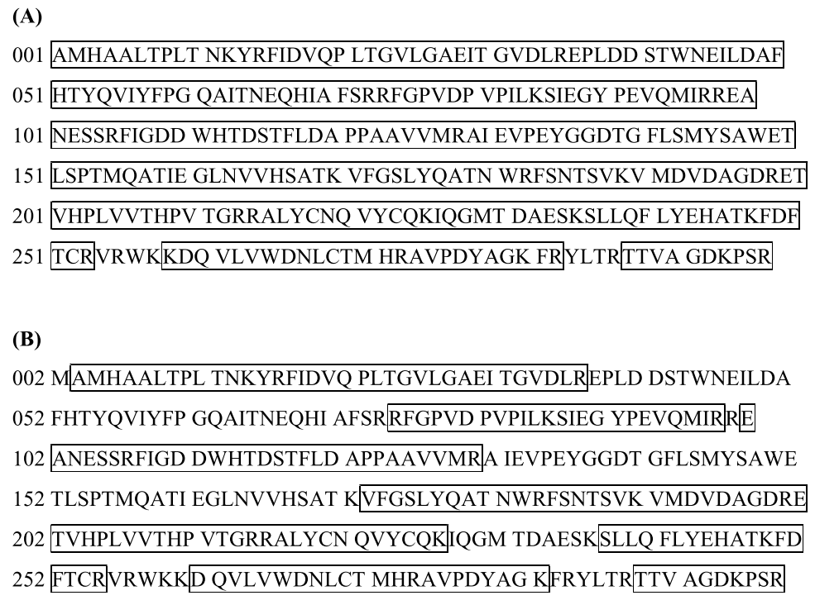
Figure 14: Tryptic Peptide Map of the MON87429-produced (A) and E. coli-produced (B) FT_T proteins. The deduced amino acid sequence is 296 amino acids as shown in (A) and (B), respectively. Boxed regions correspond to peptide sequence coverage achieved using Nano LC-MS/MS.

4.3.2.4 Western blot and immunoreactivity analysis
Western blot analysis with a FT_T-specific antibody showed that the protein being expressed in MON87429 and E. coli was FT_T protein and they have equivalent immunoreactivity.

4.3.2.5 Glycosylation analysis
An ECL detection procedure showed the FT_T protein from both MON87429 and E. coli was equivalent and that neither is glycosylated.

4.3.2.6 Functional activity analysis
A colourimetric assay that measures the amount of 2,4-DCP, the product formed from the FT_T catalysed degradation of 2,4-D, showed that MON87429- and E. coli-produced FT_T proteins had equivalent functional activity.

4.3.2.7 Conclusion
These data demonstrated that the bacterially-produced FT_T protein is a suitable:
- positive control for the Western blot experiment used to characterise the phenotypic stability of FT_T in Section 3.4.3.2;
- standard for the immunoassay study used to detect FT_T protein in plant tissues as discussed in Section 4.3.1;
- surrogate for use in the safety assessment experiments described in Section 4.3.3.

4.3.3 Safety of the introduced FT_T
Unpublished studies
Bioinformatics study
- Bioinformatics Evaluation of the DMO and FT_T Proteins in MON87429 Utilizing the AD_2018, TOX_2018, and PRT_2018 Databases (2018). Report MSL0029452. Monsanto Company.
Digestibility study
- Assessment of the in vitro Digestibility of Escherichia coli (E. coli)-produced FT_T Protein by Pepsin and Pancreatin (2018). Report MSL0029802. Monsanto Company.
Thermolability study
- The Effect of Heat Treatment on the Functional Activity of Escherichia coli (E. coli)-produced FT_T Protein (2018). Report MSL0029688. Monsanto Company.
Acute toxicity study
- An Acute Oral Gavage Toxicity Study with MON87429 FT_T Protein in CD-1 Mice (2018). Report MSL0029801. Monsanto Company.

The FT_T protein has not been previously assessed by FSANZ. Data were provided to assess the potential toxicity and allergenicity of the FT_T protein expressed in MON87429.

4.3.3.1 Bioinformatic analyses of FT_T
The Applicant provided the results of in silico analyses comparing the FT_T amino acid sequence to known allergenic proteins in the COMPARE dataset, using the same search criteria as outlined in Section 3.4.5.1. The search did not identify any known allergens with homology to FT_T. No alignments met or exceeded the threshold of greater than 35% over 80 amino acids and no eight amino acid peptide matches were shared between the FT_T protein sequence and proteins in the allergen database.

The Applicant also provided the results of in silico analyses comparing the amino acid sequence of FT_T to proteins identified as “toxins” from the NCBI protein databases. The search did not identify any known toxins with homology to FT_T.

4.3.3.2 Susceptibility of FT_T to digestion with pepsin and pancreatin
Bacterially-produced FT_T protein (test protein) was incubated with pepsin (10U enzyme/μg protein) at 37°C for 0-60 min, in a simulated gastric fluid system at an acidic pH range (Thomas et al., 2004). Controls included a no enzyme control (test protein only) and a test protein control (no enzyme) incubated for 0 and 60 min. The extent of digestion was visualised by Brilliant Blue G-Colloidal stain and western blotting. A serial dilution of the reaction mix (test protein plus enzyme) without incubation was used to determine the limit of detection (LOD) for the protein after gel staining and western blotting. In the protein gel staining analysis, 1 µg test protein was loaded per lane and the LOD was calculated to be 3.1 ng. In the western blotting experiments, 40 ng test protein was loaded and the LOD was 0.31 ng.

The results from the pepsin digestion showed that by 0.5 min, there was no intact FT_T remaining in the reaction mix. This digestion was not complete however, with transiently-stable peptide fragments of ~4 kDa being observed throughout all incubation times. There was also a slight decrease of band intensity in the no enzyme control incubated for 60 min, indicating that a small proportion of FT_T protein was unstable. However, the rapid loss FT_T in the reaction mixes containing pepsin indicates proteolytic digestion of FT_T.

Bacterially-produced FT_T protein (test protein) was also incubated with porcine pancreatin (~55 μg enzyme/μg protein) at 37°C for 0-24 h, in a simulated intestinal fluid system at a neutral pH range. Pancreatin is a mixture of proteolytic enzymes. Controls for this experiment included a no enzyme control (test protein only) and a test protein control (no enzyme) incubated for 0 and 24 h. The extent of digestion was visualised by western blotting. A serial dilution of the reaction mix (test protein plus enzyme) without incubation was used to determine the LOD for the protein after western blotting. In the western blotting experiments, 40 ng test protein was loaded and the LOD was 0.31 ng.

The results from the pancreatin digestion showed that by 5 min, there was no visible FT_T remaining in the reaction mix. There was no loss of band intensity in the no enzyme control incubated for 24 h that would indicate instability of the FT_T protein. Therefore the loss of FT_T in the reaction mix indicated the protein was being fully digested by pancreatin.

In the human digestive system, gastric digestion (pepsin) occurs before intestinal digestion (pancreatin). Therefore a sequential digestion was performed on FT_T. The pepsin digestion was run for 0 and 2 min followed by digestion of the 2 min sample by pancreatin for 0-2 h. The results showed that by 2 min, intact FT_T was digested by the pepsin and the small transiently-stable peptide fragments of ~4 kDa were completely digested within 0.5 min of pancreatin exposure. Together, these data indicate that the FT_T protein will be fully degraded by gastric and intestinal enzymes in the human digestive system.

4.3.3.3 Structural stability of FT_T after exposure to heat
Bacterially-produced FT_T protein was boiled for 15 or 30 min at temperatures ranging from 25-95°C. A control sample was kept at 4°C. An aliquot of the control and boiled protein samples were run on SDS-PAGE and stained with Brilliant Blue G-Colloidal stain to detect the extent of protein degradation. No visible degradation or decrease in band intensity was observed for the FT_T protein in the control, 25, 37, 55, 75 and 95°C treated samples at both 15 and 30 min. However, in the samples treated at 95°C for 15 and 30 min there was a slight increase in band intensity for some of the higher molecular weight species. This may show aggregation of the FT_T protein at high temperatures. These data indicate that the FT_T protein is not heat labile at all temperatures tested.

While heat treatment did not degrade the FT_T protein, heat may impact its structure and functionality. To this end, the remaining boiled protein was tested in a functional activity assay that measures the conversion of 2,4-D to 2,4-DCP (Table 9 & 10). When FT_T was incubated at 25 or 37°C for either 15 or 30 min its activity remained. Increasing the temperature to 55°C at either time points, reduced the specify of the FT_T protein. Temperatures of 75°C or above, reduced the functional activity of the FT_T protein to ≤1% of the control FT_T protein activity, regardless of the duration of heating. These data indicate that at elevated temperatures the FT_T protein becomes denatured and loses functional activity.

Table 9: Structural stability of FT_T after exposure to 15 minutes of heat
Temperature | Specific activity  (nmol x minute⁻¹ x mg⁻¹) | Relative activity  (% of control sample)¹
0°C (control) | 598 | 100%
25°C | 543 | 91%
37°C | 605 | 101%
55°C | 344 | 58%
75°C | 3 | <1%
95°C | 5 | <1%
1. The activity of the FT_T protein in the control sample was assigned 100%, with the other samples calculated relative to the control.

Table 10: Structural stability of FT_T after exposure to 30 minutes of heat
Temperature | Specific activity  (nmol x minute⁻¹ x mg⁻¹) | Relative activity  (% of control sample)¹
0°C (control) | 598 | 100%
25°C | 636 | 106%
37°C | 612 | 102%
55°C | 212 | 35%
75°C | 5 | <1%
95°C | 7 | 1%
1. The activity of the FT_T protein in the control sample was assigned 100%, with the other samples calculated relative to the control.

4.3.3.5 Acute oral toxicity study
An acute oral toxicity study in mice using E.coli-produced FT_T was submitted by the Applicant as additional supporting information but is not included in this safety assessment. FSANZ notes however that no treatment-related adverse effects were observed at oral doses of FT_T up to 2000 mg/kg bodyweight.

Acute toxicity studies are only deemed necessary if the results of the biochemical, bioinformatic, digestibility or stability studies indicate further investigation of potential toxicity is warranted or if the protein is not similar to proteins that have previously been consumed safely in food.

4.3.6 Conclusion
A range of characterisation studies were performed on plant-derived FT_T confirming the identity and functionality of the protein and equivalence to the corresponding protein produced in a bacterial expression system. Expression of FT_T in MON87429 was highest in leaf and lowest in the root. Bioinformatic analyses showed FT_T had no amino acid sequence similarity to known toxins and allergens. The protein was shown to be heat labile and susceptible to pepsin and pancreatin digestion. Taken together this indicates that the FT_T protein is unlikely to be toxic or allergenic to humans.

4.4 CP4 EPSPS protein
EPSPS proteins occur ubiquitously in plants and microorganisms and have been extensively studied over a period of forty years. EPSPS catalyses a step in the shikimate pathway that is responsible for the biosynthesis of the aromatic amino acids phenylalanine, tryptophan and tyrosine. Inhibition of this pathway in is lethal, as it deprives the organism of essential amino acids.

In plants, the EPSPS enzyme is inhibited by glyphosate (Steinrucken & Amrhein, 1980), but bacterial EPSPS enzymes, such as the CP4 EPSPS, have a reduced affinity for glyphosate (Barry et al., 2001; Padgette et al., 1996). Reduced affinity allows for the continued action of CP4 EPSPS in the presence of glyphosate. A single residue in the active site (Ala-100) renders CP4 EPSPS insensitive to glyphosate, whereas a highly conserved Gly residue is found at this position in known natural plant enzymes (Funke et al., 2006). The CP4 EPSPS protein present in corn MON87429 is functionally the same as the Agrobacterium enzyme. The parental LH244 corn line used for the genetic modification described in this application, also contains the native EPSPS protein (that is inhibited by glyphosate).

A couple of features of the cp4 epsps expression cassette (Section 3.2.4) reduces the expression of the CP4 EPSPS protein in pollen tissue. Firstly, the CaMV 35S sequence has been shown to be a weak promoter in pollen tissue although it exhibits constitutive activity in other plant tissues (Heck et al., 2005; Holtorf et al., 1995). Secondly, the siRNA target sequence is recognised by endogenous siRNA in pollen tissue and targets the cp4 epsps mRNA for degradation (Yang et al., 2018). While the same cp4 epsps mRNA will be expressed throughout MON87429 (e.g. root, leaf, ear and pollen), the cp4 epsps mRNA is targeted for degradation specifically in pollen tissue. This results in a MON87429 plant that is tolerant of glyphosate but produces a non-viable pollen phenotype. By timing the application of glyphosate, the grower is able to cross pollinate desirable maize varieties without the need to prevent self-pollination through mechanical or manual detasseling.

The cp4 epsps gene prepared by the Applicant encodes a protein of 531 amino acids, consisting of a 76 amino acid CTP and a 455 amino acid CP4 EPSPS protein. After complete cleavage of the CTP, the mature protein has an apparent molecular weight of 44.0 kDa.

4.4.1 Expression of CP4 EPSPS protein in MON87429 tissues
Unpublished studies
- Assessment of DMO, PAT (pat), FT_T and CP4 EPSPS Protein Levels in Maize Tissues Collected from MON87429 Produced in United States Field Trials During 2017 (2019). Report MSL0030257. Monsanto Company.
- Assessment of CP4 EPSPS Protein Levels in Maize Pollen Tissue Collected form MON87429 Produced in United States Field Trials During 2017, Treated with Intended Herbicides. Report SCR-2018-0601. Monsanto Company.

CP4 EPSPS expression in plant tissues was determined in the same multiplexed immunoassay study as described in Section 4.1.1. The analytical reference standard for plant-derived CP4 EPSPS, however, was generated using bacterially-expressed CP4 EPSPS, of which the characterisation is described in Section 4.4.2.

The results from the protein analysis (Table 11) showed the highest expression of CP4 EPSPS was in the leaf. This was demonstrated in leaf material collected at the leaf development (2-4) stage.

Table 11: Expression of CP4 EPSPS in MON87429 tissue samples
Tissue | Growth Stage | CP4 EPSPS (μg/g dw)³
 |  | Mean¹ | SE² | Range
Forage | R5 | 7.6 | 0.50 | 4.0-11
Grain | R6 | 0.63 | 0.028 | 0.41-0.85
Leaf | V2-V4 | 54 | 3.2 | 30-82
Root | V2-V4 | 10 | 1.7 | 3.4-29
1. Data was generated from a pooled sample of tissue for each tissue type, across all sites (n=20). 2. SE = standard error. 3. dw = dry weight.

The Applicant has provided a separate study that determined the level of CP4 EPSPS in pollen. This study had the same methodology as the study described in Section 4.1.1. The results from the protein analysis showed that the level of CP4 EPSPS in pollen was below the limit of quantitation (LOQ) (Table 12). As expected, the lowest expression of CP4 EPSPS was in the pollen.

Table 12: Expression of CP4 EPSPS in MON87429 pollen
Tissue | Growth Stage | CP4 EPSPS (μg/g dw)
 |  | Mean (SE)¹ | LOQ
Pollen | R1 | <LOQ | 0.11
1. Data was generated from a pooled sample of tissue for each tissue type, across all sites (n=12

4.4.2 Characterisation of CP4 EPSPS protein in MON87429 and equivalence to a bacterially-produced form
Unpublished study
- Characterization of the CP4 EPSPS Protein Purified from the Maize Grain of MON87429 and Comparison of the Physicochemical and Functional Properties of the Plant-Produced and Escherichia coli (E. coli)-Produced CP4 EPSPS Proteins (2018). Report MSL0029463. Monsanto Company.

The equivalence of the MON87429- and E. coli-produced CP4 EPSPS proteins must be established before the safety data generated using E. coli-produced CP4 EPSPS can be applied to MON87429-produced CP4 EPSPS protein.

The plant-produced CP4 EPSPS protein was purified from ground grain of MON87429 by chromatography and the E. coli-produced CP4 EPSPS protein was generated following the fermentation of E. coli containing a plasmid that expresses the protein.

In order to confirm the identity and equivalence for the MON87429- and E. coli-produced CP4 EPSPS proteins, a series of analytical techniques were employed:

4.4.2.1 Molecular weight analysis
Aliquots of purified MON87429- and E. coli-produced CP4 EPSPS proteins were run on SDS-PAGE then visualised with Brilliant Blue G-Colloidal stain. The MON87429- and E. coli-produced CP4 EPSPS were shown to be pure and have an apparent molecular weight of 44.0 and 43.8 kDa, respectively. These molecular weights are within acceptance limits for equivalence.

4.4.2.2 N-terminal sequencing
N-terminal sequencing of the first 15 amino acids of MON87429- and E. coli-produced CP4 EPSPS proteins showed that the sequences were as expected. Two sequences were observed for the MON87429-produced CP4 EPSPS protein: one with the N-terminal methionine that was acetylated and oxidised and the second sequence without the methionine. Acetylation and oxidation of the N-terminus methionine is a common process in eukaryotes, as is cleavage of the methionine (Wingfield 2017; Bradshaw et al., 1998). This sequence information confirms the identity of the MON87429-produced CP4 EPSPS protein.

4.4.2.3 Peptide mass fingerprint analysis
Peptide mapping showed that the protein being expressed in MON87429 and E. coli was CP4 EPSPS, with 92% and 64% sequence coverage achieved, respectively (Figure 15).
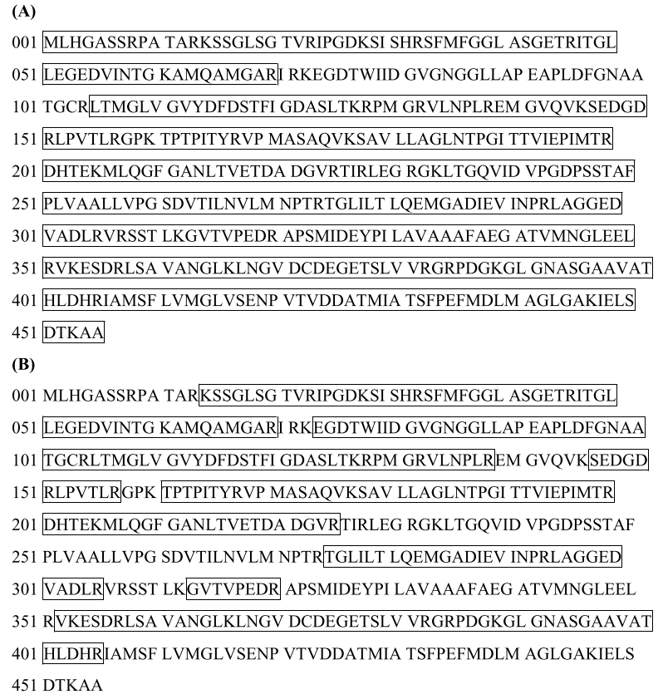
Figure 15: Tryptic Peptide Map of the MON87429-produced (A) and E. coli-produced (B) CP4 EPSPS proteins. The deduced amino acid sequence is 455 amino acids as shown. Boxed regions correspond to peptide sequence coverage achieved using Nano LC-MS/MS.

4.4.2.4 Western blot and immunoreactivity analysis
Western blot analysis with a CP4 EPSPS-specific antibody showed that the protein being expressed in MON87429 and E. coli were in fact CP4 EPSPS proteins and they have equivalent immunoreactivity.

4.4.2.5 Glycosylation analysis
An ECL detection procedure showed the CP4 EPSPS protein from both MON87429 and E. coli was equivalent and that neither is glycosylated.

4.4.2.6 Functional activity analysis
A colourimetric assay that measures the amount of inorganic phosphate, the product formed from the EPSPS-catalysed reaction between shikimate-3-phosphate and phosphoenolpyruvate, showed that MON87429- and E. coli-produced CP4 EPSPS proteins had equivalent functional activity.

4.4.2.7 Conclusion
These data demonstrated that the bacterially-produced CP4 EPSPS protein is a suitable:
- positive control for the Western blot experiment used to characterise the phenotypic stability of CP4 EPSPS in Section 3.4.3.2
- standard for the immunoassay study used to detect CP4 EPSPS protein in plant tissues as discussed in Section 4.4.1
- surrogate for use in the safety assessment experiments described in Section 4.4.3.

4.4.3 Safety of the introduced CP4 EPSPS
Unpublished studies
Bioinformatics study
- Updated Bioinformatics Evaluation of the CP4 EPSPS Protein Utilizing the AD_2018, TOX_2018, and PRT_2018 Databases (2018). Report RAR-2018-0126. Monsanto Company.
Digestibility study
- Assessment of the in vitro Digestive Fate of CP4 EPSP Synthase (1993). Report MSL12949. Monsanto Company.
- Assessment of the in vitro Digestibility of Purified E. coli-Produced CP4 EPSPS Protein in Simulated Gastric Fluid (2002). Report MSL17566. Monsanto Company.
Thermolability study
- Amended Report for MSL0022432: Effect of Temperature Treatment on the Functional Activity of CP4 EPSPS (2011). Report MSL0023307. Monsanto Company.
Acute toxicity study
- Acute Oral Toxicity Study of CP4 EPSPS Protein in Albino Mice (1993). Report MSL13077. Monsanto Company.

The CP4 EPSPS protein has now been considered in 15 FSANZ safety assessments (A338, A355, A363, A378, A383, A416, A525, A548, A553, A575, A592, A1049, A1066, A1071 and A1097) and has an extensive history of safe consumption (Delaney et al., 2008). These assessments, together with the published literature, firmly establish the safety of CP4 EPSPS and confirm that it does not raise toxicity or food allergenicity concerns in humans (ILSI 2016)

Relevant FSANZ Applications are listed in Table 13 and the detailed safety assessment reports are available on the FSANZ website. The Applicant has submitted further studies with this application (listed above). The bioinformatics study that looks for amino acid sequence similarity to known protein toxins and allergens in publicly available databases, were updated and the results do not alter conclusions reached in previous assessments. The Applicant also provided in vitro digestibility (pepsin and pancreatin) and thermolability studies for the CP4 EPSPS protein that confirmed conclusions from previous Applications as listed in Table 13. The digestibility studies indicate the CP4 EPSPS protein would be rapidly degraded in the stomach following ingestion and thermolability studies show the protein is inactivated by heating.

Table 13: Summary of considerations of CP4 EPSPS in previous FSANZ safety assessments

Consideration | Sub-Section
Potential toxicity | Amino acid sequence similarity to protein toxins | This application – using search updated in 2018
 | In vitro digestibility | A553 (FSANZ 2006)
 | Acute oral toxicity | A1071 (FSANZ 2013)
Potential allergenicity | Source of the protein | A1071 (FSANZ 2013)
 | Amino acid sequence similarity to allergens | This application – using search updated in 2018
 | Stability to heat | A1071 (FSANZ 2013)

4.4.3 Conclusion
The addition of the endogenous siRNA target sequence to the cp4 epsps expression cassette takes advantage of a natural RNA interference process in corn to regulate gene expression in pollen tissue. No protein or non-protein substance is produced as a result of incorporating the siRNA target sequence into the cp4 epsps expression cassette.

A range of characterisation studies were performed on plant-derived CP4 EPSPS confirming its identity and functionality as well as equivalence to the corresponding protein produced in a bacterial expression system. Expression of CP4 EPSPS in MON87429 was highest in leaf tissue and lowest in pollen. Bioinformatic analyses showed CP4 EPSPS had no homology to known toxins and allergens. The protein was shown to be heat labile and susceptible to pepsin and pancreatin digestion. Taken together this indicates that the CP4 EPSPS protein is unlikely to be toxic or allergenic to humans.

4.5 Novel herbicide metabolites in GM herbicide-tolerant plants
As part of the safety assessment it is important to establish whether the expression of a novel protein(s) is likely to result in the accumulation of any novel herbicide metabolites. Novel metabolites are those not normally found in non-GM crops sprayed with the same herbicide. If such substances are found to occur as a result of the genetic modification, then it is important to determine their potential toxicity. There are a number of mechanisms of herbicide tolerance that exist, but only the detoxification of a herbicide to inactive forms may result in the production of novel metabolites. This mechanism of herbicide tolerance is used in the case of PAT, DMO and FT_T, but not for EPSPS, which uses a herbicide tolerant form of EPSPS that functions in place of the herbicide sensitive endogenous EPSPS.

A second consideration for GM foods derived from crops that are herbicide tolerant, which is separate from the GM food approval process and therefore not included as part of this safety assessment, relates to the presence of herbicide residues on the food. Any food products (whether derived from GM or non-GM sources) sold in both Australia and New Zealand must not have residue levels greater than the relevant maximum residue limit (MRL). Where necessary, an MRL may have to be set.

For PAT and DMO, the metabolic profiles resulting from the novel protein x herbicide interaction have been established. The glufosinate-tolerance trait (PAT) and dicamba-tolerance trait (DMO) is present in lines from 24 and 3 previous Applications to FSANZ, respectively. These previous assessments indicate the spraying of MON87429 with glufosinate ammonium or dicamba results in the same metabolites that are also produced in non-GM crops sprayed with the same herbicides.

The FT_T protein has not been previously assessed by FSANZ. It is therefore necessary to establish whether 2,4-D or a FOP herbicide (e.g. quizalofop-P-ethyl) applied to MON87429 results in the accumulation of novel herbicide metabolites. Two unpublished studies were provided by the Applicant and are the subject of assessment below.

4.5.1 Metabolism of 2,4-D
Unpublished studies

- Nature of 14C-2,4-Dichlorophenoxyacetic Acid (2,4-D) Residues in/on Corn Raw Agricultural Commodities Following Preemergence or Postemergence Application to Herbicide Tolerant Maize, MON87429 (2018). Report MSL0029509. Monsanto Company.

A metabolism study with radiolabelled [¹⁴C]2,4-D in 2,4-D tolerant corn (MON87429) was conducted as part of the herbicide registration requirements in the U.S., and therefore also considered elsewhere including in Australia. The purpose of using radiolabelled 2,4-D was to determine the nature of residues found in or on agricultural commodities of 2,4-D tolerant corn, following pre- or post-emergence treatments with the herbicide. Immature plants, forage, stover, grain and cobs were harvested for analysis.

The 2,4-D metabolite profile produced in MON87429 is consistent with what has been observed with other 2,4-D tolerant plants as well as non-GM plants. As a result of the activity of FT_T, the major herbicide metabolite generated by corn line MON87429 sprayed with 2,4-D is 2,4-DCP. 2,4-DCP subsequently becomes conjugated into other forms. The Applicant proposed a metabolic pathway for 2,4-D in 2,4-D tolerant corn whereby the cleavage of the acetic acid chain of 2,4-D by FT_T forms the 2,4-DCP metabolite (Figure 13). The side chain cleavage of 2,4-D to form 2,4-DCP has been observed in many conventional plants (Peterson et al., 2016; Loos 1969). That is, no herbicide metabolites are produced in MON87429 that are not also produced in conventional crops treated with 2,4-D herbicide.

4.5.2 Metabolism of quizalofop-P-ethyl
Unpublished studies

- Nature of14C-Quizalofop-P-Ethyl Residues in/on Corn Raw Agricultural Commodities Following Postemergence Application to Herbicide Tolerant Maize, MON87429 (2018). Report MSL0029508. Monsanto Company.

A metabolism study with radiolabelled [¹⁴C]quizalofop-P-ethyl in quizalofop-P-ethyl tolerant corn (MON87429) was conducted as part of the herbicide registration requirements in the U.S., and therefore also considered elsewhere including in Australia. The purpose of using radiolabelled quizalofop-P-ethyl was to determine the nature of residues found in or on agricultural commodities of quizalofop-P-ethyl tolerant corn, following post-emergence treatments with the herbicide. Forage, stover, grain and cobs were harvested for analysis.

As a result of the activity of FT_T, the herbicide metabolite generated by corn line MON87429 spayed with quizalofop-P-ethyl is quizalofop phenol. The Applicant proposed a metabolic pathway for quizalofop-P-ethyl in quizalofop tolerant corn. In this pathway, rapid hydrolysis of the ethyl-ester moiety of the quizalofop-P-ethyl to from quizalofop-P acid is then rapidly followed by the cleavage of the propionic acid chain of the quizalofop-P acid by FT_T to form quizalofop phenol (Figure 13). Quizalofop phenol is detected in conventional crops sprayed with quizalofop herbicide (Roberts et al., 2007; Koeppe et al., 1990). That is, no herbicide metabolites are produced in MON87429 that are not also produced in conventional crops treated with quizalofop herbicides.

5 Compositional analysis
The main purpose of compositional analyses is to determine if, as a result of the genetic modification, an unexpected change has occurred to the food. These changes could take the form of alterations in the composition of the plant and its tissues and thus its nutritional adequacy. Compositional analyses can also be important for evaluating the intended effect where there has been a deliberate change to the composition of the food.

The classic approach to the compositional analyses of GM food is a targeted one. Rather than analysing every possible constituent, which would be impractical, the aim is to analyse only those constituents most relevant to the safety of the food or that may have an impact on the whole diet. Important analytes therefore include the key nutrients, toxicants and anti-nutrients for the food in question. The key nutrients and anti-nutrients are those components in a particular food that may have a substantial impact in the overall diet. They may be major constituents (fats, proteins, carbohydrates or enzyme inhibitors such as anti-nutrients) or minor constituents (minerals, vitamins). Key toxicants are those toxicologically significant compounds known to be inherently present in an organism, such as compounds whose toxic potency and level may be significant to health.

5.1 Key Components
For corn, there are a number of components that are considered important for a compositional analysis (OECD 2002). As a minimum, the key nutrients of corn grain appropriate for a comparative study include the proximates (crude protein, fat, ash, acid detergent fibre and neutral detergent fibre), amino acids and fatty acids. In addition, mineral and vitamin levels may be considered and international guidance also suggests that levels of the key anti-nutrients and secondary metabolites could be determined for new varieties of corn.

Corn contains a number of substances described as anti-nutrients: phytic acid, raffinose, 2,4-dihydroxy-7-methoxy-2H-1,4-benzoxazin-3(4H)-one (DIMBOA) and trypsin and chymotrypsin inhibitor.

DIMBOA is present at highly variable levels in corn hybrids and little evidence is available on either its toxicity or anti-nutritional effects; corn contains only low levels of trypsin and chymotrypsin inhibitor, neither of which is considered nutritionally significant. Only phytic acid and raffinose are considered to be biologically relevant for corn (OECD 2002).

Phytic acid is considered an important anti-nutrient for animals, especially non-ruminants, since it can significantly reduce the bioavailability of minerals. Raffinose is a non-digestible oligosaccharide and is considered an anti-nutrient because of its undesirable gastrointestinal effects (flatulence).

Secondary metabolites in plants are defined as those natural products that do not function directly in the primary biochemical reactions that support normal growth, development and reproduction in the organism. Secondary plant metabolites are neither nutrients nor anti-nutrients but are sometimes analysed in a GM crop as further indicators of the absence of unintended effects on plant metabolism as a result of the genetic modification (OECD 2002). Characteristic secondary metabolites in corn are furfural and the phenolic acids, ferulic acid and p-coumaric acid.

There are no generally recognised anti-nutrients in corn at levels considered to be harmful, but for the purposes of comparative assessment, the OECD has recommended considering analytical data for the content of the anti-nutrients phytic acid and raffinose, and the secondary metabolites furfural, ferulic acid and p-coumaric acid.

5.2 Study design
Unpublished study
- Compositional Analyses of Maize Grain and Forage Harvested from MON87429 Grown in the United States During the 2017 Season (2018). Report MSL0029410. Monsanto Company.

The purpose of the compositional analyses is to compare a targeted range of constituents in the GM crop and the conventional counterpart, to determine whether the genetic modification has resulted in any biologically significant changes.

MON87429 generation R3F1 (LH244 x HCL617) (Figure 7) was used for these analyses (test) and was verified by event-specific PCR. Ideally, the comparator in compositional analyses should be the non-transformed parental line grown concurrently under similar field conditions (OECD 2002). In this case, the LH244 x HCL617 line has a genetic background similar to MON87429 and has been used as the near-isogenic control (‘the comparator’).

The test and control lines were planted in a randomized complete block design with four replicates at each of five field sites in the U.S. during the 2017 growing season. All plantings at the field sites were grown under normal agricultural field conditions for their respective geographical regions. MON87429 plots were treated with glufosinate, dicamba, 2,4-D and quizalofop to simulate conditions of intended use of the product. The control line was not treated with the herbicides. Grain was harvested at physiological maturity and shipped at ambient temperature to laboratories for analysis. Forage was harvested at the R5 growth stage and shipped on dry ice.

Grain samples were analysed for proximates (protein, fat, ash), amino acids, fatty acids, carbohydrates by calculation, fibre, minerals, vitamins, anti-nutrients and secondary metabolites. In total, 68 different analytes were measured in grain.

Methods of composition analysis were based on internationally recognised procedures (e.g. those of the Association of Official Analytical Chemists), methods specified by the manufacturer of the equipment used for analysis, or other published scientific methods.

Statistical analyses were performed using SAS 9.4 (SAS Institute, Cary, NC). For each analyte the mean and standard error (SE) were generated. A mixed model analysis of variance was then applied to the combined data covering the 5 replicated field trial sites. In assessing the significance of any difference between the mean analyte value for MON87429 and the comparator, a P-value of 0.05 was used.

In order to complete the statistical analysis for any component in this study, it was deemed that more than 50% of the values must be greater than the assay limit of quantitation (LOQ). If analytes had more than 50% of observations below the LOQ for that assay, they were excluded from the overall summary analysis. Values for all components were expressed on a dry weight (dw) basis with the exception of fatty acids, expressed as percent of total fatty acids.

As well as the quantitative comparison between MON87429 and the control line, the composition of MON87429 was also evaluated in the context of natural variability defined by published literature values (Ridley et al., 2011; Harrigan et al., 2009; Egesel et al., 2003) or the ILSI Crop Composition Database (v.6, ILSI-CCDB). Natural variation in crop composition due to environmental and germplasm differences is well described in agricultural science. Consideration of the breadth of natural variability is therefore important for interpreting the biological relevance of any statistically significant differences between MON87429 and its comparator. The combined data of published literature values and ILSI database v.6 (Applicant search) and v.7 (FSANZ search) is shown as the reference range (minimum – maximum) in the data tables (Tables 14 – 19).

Key analyte levels (proximates, carbohydrates, fibre and minerals) were also analysed in forage but the results are not included in this report. It is noted however that, in the combined site analysis, none of the analyte levels in MON87429 differed significantly from those of the control.

5.3 Analyses of key components in grain

5.3.1 Protein and amino acids
Typically, maize grain is approximately 10% protein by weight. The level of protein and associated amino acids vary widely with the local growing conditions. The results of the analyses for protein and 18 amino acids are shown in Table 14. There were no statistically significant differences found in the level of the protein and 18 amino acids analysed in MON87429 compared to the control (Table 14). All means were also within the reference range.

Table 14: Comparison of Protein and Amino Acids (% dw)
Analyte  (% dw) | Control Mean (SE) | MON87429 Mean (SE) | p value | Reference range (Min- Max)
Protein | 9.35 (0.30) | 9.20 (0.30) | ns¹ | 5.72-17.26
Alanine | 0.73 (0.028) | 0.72 (0.028) | ns | 0.40-1.48
Arginine | 0.45 (0.014) | 0.45 (0.014) | ns | 0.19-0.708
Aspartic acid | 0.61 (0.019) | 0.61 (0.019) | ns | 0.298-1.208
Cystine | 0.20 (0.0062) | 0.2 (0.0062) | ns | 0.116-0.514
Glutamic acid | 1.78 (0.074) | 1.77 (0.074) | ns | 0.832-3.540
Glycine | 0.36 (0.0089) | 0.36 (0.0089) | ns | 0.184-0.685
Histidine | 0.25 (0.0091) | 0.26 (0.0091) | ns | 0.137-0.456
Isoleucine | 0.34 (0.013) | 0.34 (0.013) | ns | 0.179-0.692
Leucine | 1.22 (0.054) | 1.20 (0.054) | ns | 0.604-2.492
Lysine | 0.26 (0.0077) | 0.26 (0.0077) | ns | 0.129-0.668
Methionine | 0.20 (0.0067) | 0.20 (0.0067) | ns | 0.105-0.468
Phenylalanine | 0.48 (0.020) | 0.48 (0.020) | ns | 0.244-0.930
Proline | 0.89 (0.040) | 0.88 (0.040) | ns | 0.462-1.750
Serine | 0.46 (0.015) | 0.46 (0.015) | ns | 0.152-0.769
Threonine | 0.34 (0.0097) | 0.34 (0.0097) | ns | 0.173-0.666
Tryptophan | 0.075 (0.0016) | 0.074 (0.0016) | ns | 0.0271-0.2150
Tyrosine | 0.39 (0.013) | 0.40 (0.013) | ns | 0.103-0.734
Valine | 0.44 (0.015) | 0.44 (0.015) | ns | 0.266-0.855
1. ns – not significant

5.3.2 Total fat and fatty acids
Maize grain is approximately 4% fat; the levels of total fat and individual fatty acids can vary widely with the field conditions at the time of growing. Total fat and 22 fatty acids were measured in MON87429 and the control grain. Of these, the following had ≥50% of observations below the LOQ and were therefore excluded from analysis - C8:0 caprylic, C10:0 capric, C12:0 lauric, C14:0 myristic, C14:1 myristoleic, C15:0 pentadecanoic, C15:1 pentadecenoic, C17:0 heptadecanoic, C17:1 heptadecenoic, C18:3 gamma linolenic, C20:2 eicosadienoic, C20:3 eicosatrienoic, and C20:4 arachidonic acid. These fatty acids are typically present in low amounts in maize grain, if present at all. Results for total fat and the remaining 9 fatty acids are given in Table 15. Statistically significant differences between MON87429 and control were observed for a range of fatty acids (Table 15). However, the magnitude of these differences was actually small and do not significantly change the composition of the oil. Additionally, the differences were also within the range variability determined for the conventional control and the mean values fall within the reference ranges. Therefore, these differences are not considered biologically significant.

Table 15: Comparison of Total Fat (% dw) and Fatty Acids (% total fat acids)
Analyte  (% dw) | Control Mean (SE) | MON87429 Mean (SE) | p value | Reference range (Min- Max)
Total fat | 3.88 (0.050) | 3.76 (0.050) | 0.049 | 1.363-7.830
Palmitric acid | 12.83 (0.048) | 12.91 (0.048) | ns¹ | 5.002-28.984
Palmitoleic acid | 0.12 (0.0062) | 0.13 (0.0062) | <0.001 | 0.059-0.556
Stearic acid | 1.66 (0.054) | 1.74 (0.054) | 0.010 | 0.836-4.888
Oleic acid | 28.15 (0.52) | 27.64 (0.52) | <0.001 | 11.211-66.561
Linoleic acid | 55.21 (0.63) | 55.53 (0.63) | 0.018 | 15.301-90.631
Linolenic acid | 1.21 (0.022) | 1.24 (0.022) | <0.001 | 0.244-2.528
Arachidic acid | 0.41 (0.011) | 0.41 (0.011) | ns | 0.206-1.248
Eicosenoic acid | 0.25 (0.0027) | 0.25 (0.0027) | ns | 0.065-1.952
Behenic acid | 0.15 (0.0053) | 0.16 (0.0053) | 0.040 | 0.088-0.480
Cells highlighted in blue show statistically significant differences.1. ns – not significant.

5.3.3 Carbohydrates and fibre
Maize grain is typically composed of approximately 85% carbohydrates by calculation, including fibre [acid detergent fibre (ADF); neutral detergent fibre (NDF); total dietary fibre (TDF)]. As is true for protein and fat levels in maize grain, the amounts of carbohydrate vary widely, depending on local growing conditions. The results of analyses (Table 16) show there were no significant differences in the levels of carbohydrates between MON87429 and the control. The overall amounts of these components was also within reference ranges.

Table 16: Comparison of Carbohydrates by calculation and fibre (% dw)
Analyte  (% dw) | Control Mean (SE) | MON87429 Mean (SE) | p value | Reference range (Min- Max)
Carbohydrates by calculation | 85.61 (0.38) | 85.87 (0.38) | ns¹ | 77.4-89.7
ADF | 2.53 (0.078) | 2.63 (0.078) | ns | 1.41-11.34
NDF | 8.05 (0.16) | 7.82 (0.16) | ns | 4.28-24.30
TDF | 10.61 (0.30) | 11.16 (0.30) | ns | 5.78-35.31
1. ns – not significant.

5.3.4 Ash and minerals
The levels of minerals (constituents of ash) are known to vary widely according to growing conditions. Ash and mineral components (calcium, copper, iron, magnesium, manganese, phosphorus, potassium, sodium and zinc) in grain from MON87429 and the control were measured and the results obtained for these analytes are shown in Table 17. No statistically significant differences were observed for ash, calcium, manganese, phosphorus, potassium and zinc. A statistically significant difference between MON87429 and the control was observed for copper, iron and magnesium (Table 17). Sodium was excluded from statistical analysis because more than half of the samples returned values that were below the assay LOQ.

The difference in mean values for copper, iron and magnesium between MON87429 and the control was 0.29 mg/kg dw, 0.85 mg/kg dw and 0.0050 % dw, respectively. This represents a small overall difference that was within the range variability determined for the conventional control: 1.11-2.93 mg/kg dw for copper, 15.43-19.77 mg/kg for iron and 0.095-0.13 % dw for magnesium. Since the MON87429 mean copper, iron and magnesium values were also within the reference ranges, these differences are not considered biologically significant.

Table 17: Comparison of Ash and Minerals
Analyte | Unit | Control Mean (SE) | MON87429 Mean (SE) | p value | Reference range (Min- Max)
Ash | % dw | 1.15 (0.057) | 1.15 (0.057) | ns¹ | 0.616-6.282
Calcium | % dw | 0.0032 (0.00024) | 0.0030 (0.00024) | ns | 0.0012-0.101
Copper | mg/kg dw | 1.65 (0.11) | 1.36 (0.11) | 0.029 | 0.55-21.20
Iron | mg/kg dw | 17.40 (0.50) | 16.55 (0.50) | <0.001 | 9.51-191.00
Magnesium | % dw | 0.11 (0.0037) | 0.10 (0.0037) | 0.004 | 0.059-0.194
Manganese | mg/kg dw | 4.77 (0.48) | 4.65 (0.48) | ns | 1.69-14.30
Phosphorus | % dw | 0.28 (0.018) | 0.28 (0.018) | ns | 0.13-0.552
Potassium | % dw | 0.34 (0.011) | 0.34 (0.011) | ns | 0.181-0.603
Zinc | mg/kg dw | 17.01 (0.93) | 16.56 (0.93) | ns | 6.5-42.6
Cells highlighted in blue show statistically significant differences.1. ns – not significant.

5.3.5 Vitamins
The levels of 7 vitamins, as shown in Table 18, were measured. A statistically significant difference between MON87429 and the control was observed for Vitamin E (Table 18). The difference in mean values for Vitamin E between MON87429 and the control was 0.89 mg/kg dw. This represents a small overall difference that was within the range variability determined for the conventional control: 9.50-12.56 mg/kg dw. Since the MON87429 mean vitamin A value was also within the reference ranges, this differences is not considered biologically significant.

Table 18: Comparison of Vitamins (mg/kg dw)
Analyte  (% dw) | Control Mean (SE) | MON87429 Mean (SE) | p value | Reference range (Min- Max)
Vitamin A | 1.02 (0.038) | 1.05 (0.038) | ns¹ | 0.19-49.90
Vitamin B₁ | 4.10 (0.094) | 4.16 (0.094) | ns | 1.26-40.00
Vitamin B₂ | 1.70 (0.044) | 1.70 (0.044) | ns | 0.50-7.35
Vitamin B₃ | 20.35 (0.68) | 20.28 (0.68) | ns | 7.42-46.94
Vitamin B₆ | 5.31 (0.16) | 5.22 (0.16) | ns | 1.18-12.14
Vitamin B₉ | 0.63 (0.031) | 0.61 (0.031) | ns | 0.09-3.50
Vitamin E | 10.74 (0.32) | 9.84 (0.32) | 0.013 | 0.84-68.67
Cells highlighted in blue show statistically significant differences. 1. ns – not significant.

5.3.6 Anti-nutrients and Secondary Metabolites
Anti-nutrients (phytic acid and raffinose) and secondary metabolites (ferulic acid, furfural and p-coumaric acid) in grain from MON87429 and the control were measured and the results obtained for these analytes are shown in Table 19. No statistically significant differences were observed for phytic acid, raffinose, ferulic acid and p-coumaric acid. Furfural was excluded from statistical analysis because more than half of the samples returned values that were below the assay LOQ. All recorded means also fell within reference ranges.

Table 19: Comparison of Anti-nutrients (% dw) and Secondary Metabolites (µg/g dw)
Analyte | Control Mean (SE) | MON87429 Mean (SE) | p value | Reference range (Min- Max)
Anti-nutrients (% dw)
Phytic acid | 0.67 (0.060) | 0.64 (0.060) | ns¹ | 0.111-1.940
Raffinose | 0.16 (0.020) | 0.15 (0.020) | ns | 0.020-0.466
Secondary metabolites (µg/g dw)
Ferulic acid | 1871.55 (25.74) | 1879.28 (25.74) | ns | 291.93-4397.30
p-coumaric acid | 130.19 (6.18) | 133.30 (6.18) | ns | 53.4-820.0
1. ns – not significant.

5.4 Conclusion
Of the 68 analytes measured in maize grain, mean values were provided for 53 analytes. A summary of the 11 analytes that showed a significant difference between corn line MON87429 and the control is provided in Table 20.

For the majority of analytes presented in Table 20, the differences in magnitude between MON87429 and control were within 10%, with the exception of copper, where there was an approximate change of minus (-) 18%. Regardless of these changes, the mean values were well within the reference ranges reported in the published literature (Ridley et al., 2011; Harrigan et al., 2009; Egesel et al., 2003) and from the ILSI Crop Compositional Database. As the composition of corn can vary significantly due to growing conditions, the differences reported here most likely reflect the normal biological variability that exists in corn.

Overall, the compositional data are consistent with the conclusion that there are no biologically significant differences in the levels of key constituents in MON87429 when compared with conventional corn cultivars already available in agricultural markets. Grain from MON87429 can therefore be regarded as equivalent in composition to grain from conventional corn.

Table 20: Summary of statistically significant compositional differences between control and MON87429
Analyte | Control Mean (SE) | MON87429 Mean (SE) | Are values within the reference ranges?
 |  |  | Yes / No
Total fat (% dw) | 3.88 (0.050) | 3.76 (0.050) | Yes
Palmitoleic acid (% total fat) | 0.12 (0.0062) | 0.13 (0.0062) | Yes
Stearic acid | 1.66 (0.054) | 1.74 (0.054) | Yes
Oleic acid | 28.15 (0.52) | 27.64 (0.52) | Yes
Linoleic acid | 55.21 (0.63) | 55.53 (0.63) | Yes
Linolenic acid | 1.21 (0.022) | 1.24 (0.022) | Yes
Behenic acid | 0.15 (0.0053) | 0.16 (0.0053) | Yes
Copper | 1.65 (0.11) | 1.36 (0.11) | Yes
Iron | 17.40 (0.50) | 16.55 (0.50) | Yes
Magnesium | 0.11 (0.0037) | 0.10 (0.0037) | Yes
Vitamin E | 10.74 (0.32) | 9.84 (0.32) | Yes
Cells highlighted in red show data where MON87429 is significantly lower than the control and cell highlighted in green show data where MON87429 is significantly higher than the control.

6 Nutritional impact
In assessing the safety of a GM food, a key factor is the need to establish that the food is nutritionally adequate and will support typical growth and wellbeing. In most cases, this can be achieved through a detailed understanding of the genetic modification and its consequences, together with an extensive compositional analysis of the food, such as that presented in Section 5 of this report.

Where a GM food has been shown to be compositionally equivalent to conventional varieties, the evidence to date indicates that feeding studies using target livestock or other animal species will add little to the safety assessment (Bartholomaeus et al., 2013; OECD, 2003). If the compositional analysis indicates biologically significant changes, either intended or unintended, to the levels of certain nutrients in the GM food, additional nutritional studies should be undertaken to assess the potential impact of the changes on the whole diet.

MON87429 is the result of genetic modifications to confer tolerance to herbicides, with no intention to significantly alter nutritional parameters in the food. The compositional analyses have demonstrated that the genetic modifications have not altered the nutritional adequacy of MON87429 as a source of food when compared with that of conventional corn varieties. The introduction of food derived from MON87429 into the food supply is therefore expected to have negligible nutritional impact.

7 References
Alarcón A, Davies JFT, Autenrieth RL, Zuberer DA (2008) Arbuscular mycorrhiza and petroleum-degrading microorganisms enhance phytoremediation of petroleum-contaminated soil. International Journal of Phytoremediation 10:251–263
Anderson JE, Michno JM, Kono TJ, Stec AO, Campbell BW, Curtin SJ, Stupar RM (2016) Genomic variation and DNA repair associated with soybean transgenesis: A comparison to cultivars and mutagenized plants. BMC Biotechnology 16:41
Armstrong MF (2001) Inbred corn line LH244. Patent US 6,252,148 B1 Patent Application 09/455,440. https://patents.google.com/patent/US6252148
Barker RF, Idler KB, V TD, Kemp JD (1983) Nucleotide sequence of the T-DNA region from the Agrobacterium tumefaciens octopine Ti plasmid pTi15955. Plant Mol.Biol. 2:335-350
Bartholomaeus A, Parrott W, Bondy G, Walker K (2013) The use of whole food animal studies in the safety assessment of genetically modified crops: Limitations and recommendations. Crit Rev Toxicol 43(S2):1-24
Barry GF, Kishore GM, Padgette SR and Stallings WC (2001) Glyphosate-tolerant 5enolpyruvylshikimate-3-phosphate synthases. Patent 6,248,876, U.S. Patent Office, Washington, D.C.
Bauer R, Bekker JP, van Wyk N, du Toit C, Dicks LMT, Kossmann J (2009) Exopolysaccharide production by lactose-hydrolyzing bacteria isolated from traditionally fermented milk. International Journal of Food Microbiology 131(2-3):260–264
Behrens M, Mutlu N, Chakraborty S, Dumitru R, Jiang W, LaVallee B, Herman P, Clemente T, Weeks D (2007) Dicamba Resistance: Enlarging and preserving biotechnology-based weed management strategies. Science 316: 1185-1188
Bradshaw RA, Brickey WW, Walker KW (1998) N-terminal processing: The methionine aminopeptidase and Na-acetyl transferase families. Trends in Biochemical Sciences 23:263-267
CERA (2011) A review of the environmental safety of the PAT protein. Environmental Biosafety Research 10:73–101. DOI: 10.1051/ebr/2012004
CFIA (1994) The biology of Zea mays L. (corn/maize). BIO1994-11. Canadian Food Inspection Agency, Ottawa. http://www.inspection.gc.ca/plants/plants-with-novel-traits/applicants/directive-94-08/biology-documents/zea-mays-l-/eng/1330985739405/1330985818367
Chakraborty S, Behrens M, Herman P, Arendsen A, Hagen W, Carlson D, Wang X-Z, Weeks D (2005) A three-component dicamba O-demethylase from Pseudomonas maltophilia, strain DI-6: Purification and characterization. Archives of Biochemistry and Biophysics 437: 20-28
Chaudhardy DK, Jeong SW, Kim J (2017) Sphingobium naphthae sp. nov., with the ability to degrade aliphatic hydrocarbons, isolated from oil-contaminated soil. International Journal of Systematic and Evolutionary Microbiology 67:2986-2993
Cornejo MJ, Luth D, Blankenship KM, Anderson OD, Blechl AE (1993) Activity of a maize ubiquitin promoter in transgenic rice. Plant Molecular Biology 23:567-581
CRA (2006) Corn oil. 5 ed, Corn Refiners Association, Washington D.C. http://www.corn.org/wp-content/uploads/2009/12/CornOil.pdf.
Delaney B, Astwood JD, Cunny H, Eichen Conn R, Herouet-Guicheney C, MacIntosh S, Meyer LS, Privalle LS, Gao Y, Mattsson J, Levine M, ILSI (2008) Evaluation of protein safety in the context of agricultural biotechnology. Food Chem Toxicol 46:S71-S97
Denton M, Todd NJ, Kerr KG, Hawkey PM, Littlewood JM (1998) Molecular epidemiology of Stenotrophomonas maltophilia isolated from clinical specimens from patients with cystic fibrosis and associated environmental samples. Journal of Clinical Microbiology 36:1953-1958
Depicker A, Stachel S, Dhaese P, Zambryski P, Goodman HM (1982) Nopaline synthase: transcript mapping and DNA sequence. J Mol Appl Genet 1:561-573
D'Ordine, RL, Rydel TJ, Storek MJ, Sturman EJ, Moshiri F, Bartlett RK, Brown GR, Eilers RJ, Dart C, Qi Y, Flasinski S, Franklin SJ (2009) Dicamba monooxygenase: Structural insights into a dynamic Rieske oxygenase that catalyzes an exocyclic monooxygenation. Journal of Molecular Biology 392:481-497
Duke S (2005) Taking stock of herbicide-resistant crops ten years after introduction. Pest Management Science 61: 211-218
Dumitru R, Jiang WZ, Weeks DP, Wilson MA (2009) Crystal structure of dicamba monooxygenase: A Rieske nonheme oxygenase that catalyzes oxidative demethylation. Journal of Molecular Biology 392:498-510
EFSA (2011) Conclusion on the peer review of the pesticide risk assessment of the active substance dicamba. The EFSA Journal 9(1):1965 [52 pp.] Online: www.efsa.europa.eu/efsajournal.htm
Egesel CO, Wong JC, Lambert RJ, Rocheford TR (2003) Gene dosage effects on carotenoid concentration in maize grain. Maydica 48:183-190
Enya J, Shinohara H, Yoshida S, Tsukiboshi T, Negishi H, Suyama K, Tsushima S (2007) Culturable Leaf-Associated Bacteria on Tomato Plants and Their Potential as Biological Control Agents. Microbial Ecology 53(4):524–536
FAOSTAT (2017) Online database of the Food and Agriculture Organization of the United Nations. http://www.fao.org/faostat/en/#data/QC
Fialho A, Moreira L, Granja A, Popescu A, Hoffmann K, Si-Correia I (2008) Occurrence, production, and applications of gellan: current state and perspectives. Applied Microbiology and Biotechnology 79(6):889–900
FSANZ (2016) Application A1118 - Food derived from herbicide-tolerant corn line MON87419. Report prepared by Food Standards Australia New Zealand. https://www.foodstandards.gov.au/code/applications/Pages/A1118GM-CornLineMON87419.aspx
FSANZ (2014a) Application A1080 - Food derived from herbicide-tolerant cotton line MON88701. Report prepared by Food Standards Australia New Zealand. https://www.foodstandards.gov.au/code/applications/Pages/A1080-Food-derived-from-Herbicide-tolerant-Cotton-Line-MON88701.aspx
FSANZ (2014b) Application A1081 - Food derived from herbicide-tolerant soybean event SYHT0H26. Report prepared by Food Standards Australia New Zealand. https://www.foodstandards.gov.au/code/applications/Pages/a1081foodderivedfrom5825.aspx
FSANZ (2013) Application A1071 - Food derived from herbicide-tolerant canola Line MON88302. Report prepared by Food Standards Australia New Zealand. https://www.foodstandards.gov.au/code/applications/pages/applicationa1071food5499.aspx
FSANZ (2012a) Application A1063 - Food derived from herbicide-tolerant soybean MON87708. Report prepared by Food Standards Australia New Zealand. https://www.foodstandards.gov.au/code/applications/pages/applicationa1063food5198.aspx
FSANZ (2012b) Application A1066 - Food derived from herbicide-tolerant maize MON87427. Report prepared by Food Standards Australia New Zealand. https://www.foodstandards.gov.au/code/applications/pages/applicationa1066food5286.aspx
FSANZ (2006) Application A553 - Food derived from glyphosate-tolerant cotton line MON88913. Report prepared by Food Standards Australia New Zealand. https://www.foodstandards.gov.au/code/applications/pages/applicationa553foodd2833.aspx
FSANZ (2001) Application A385 – Insect protected Bt-176 corn. Report prepared by Food Standards Australia New Zealand. https://www.foodstandards.gov.au/code/applications/pages/applicationa385insec939.aspx
Funke T, Han H, Healy-Fried ML, Fischer M, Schönbrunn E (2006) Molecular basis for the herbicide resistance of Roundup Ready crops. Proceedings of the National Academy of Sciences 103(35):13010–13015
Green Pool (2012) Sugar consumption in Australia - a statistical update. Green Pool Commodity Specialists, Brisbane. Available online at https://greenpoolcommodities.com/news/sugar-consumption-australia-statistical-update/
Hammond BG, Jez JM (2011) Impact of food processing on the safety assessment for proteins introduced into biotechnology-derived soybean and corn crops. Food and Chem Tox 49: 711-721
Harrigan, GG, Ridley WP, Miller KD, Sorbet R, Riordan SG, Nemeth MA, Reeves W, Pester TA (2009) The forage and grain of MON 87460, a drought-tolerant corn hybrid, are compositionally equivalent to that of conventional corn. Journal of Agricultural and Food Chemistry 57:9754-9763
Hausinger RP (2004) Fe(II)/α-Ketoglutarate-dependent hydroxylases and related enzymes. Critical Reviews in Biochemistry and Molecular Biology 39:21-68
Heck, GR, Armstrong CL, Astwood JD, Behr CF, Bookout JT, Brown SM, Cavato TA, DeBoer DL, Deng MY, George C, Hillyard JR, Hironaka CM, Howe AR, Jakse EH, Ledesma BE, Lee TC, Lirette RP, Mangano ML, Mutz JN, Qi Y, Rodriguez RE, Sidhu SR, Silvanovich A, Stoecker MA, Yingling RA You J (2005) Development and characterization of a CP4 EPSPS-based, glyphosate-tolerant corn event. Crop Science 45:329-339
Herman PL, Behrens M, Chakraborty S, Chrastil BM, Barycki J, Weeks DP (2005) A three-component dicamba O-demethylase from Pseudomonas maltophilia, strain DI-6: Gene isolation, characterization, and heterologous expression. Journal of Biological Chemistry 280:24759-24767
Hérouet C, Esdaile DJ, Mallyon BA, Debruyne E, Schulz A, Currier T, Hendrickx K, van der Klis R-J and Rouan D (2005) Safety evaluation of the phosphinothricin acetyltransferase proteins encoded by the pat and bar sequences that confer tolerance to glufosinate-ammonium herbicide in transgenic plants. Regulatory Toxicology and Pharmacology 41:134-149
Herrmann KM (1995) The shikimate pathway: Early steps in the biosynthesis of aromatic compounds. The Plant Cell 7:907-919
Holtorf S, Apel K, Bohlmann H (1995) Comparison of different constitutive and inducible promoters for the overexpression of transgenes in Arabidopsis thaliana. Plant Molecular Biology 29:637-646
Hunt AG (1994) Messenger RNA 3' end formation in plants. Annual Review of Plant Physiology and Plant Molecular Biology 45:47-60
ILSI Research Foundation (2016) A Review of the Food and Feed Safety of the EPSPS Protein. Available at https://ilsirf.org/publication/a-review-of-the-food-and-feed-safety-of-the-epsps-protein/
Jin D, Kong X, Cui B, Bai Z, Zhang H (2013) Biodegradation of di-n-butyl phthalate by a newly isolated Halotolerant Sphingobium sp. International Journal of Molecular Sciences 14:24046-24054
Klee HJ, Muskopf YM, Gasser CS (1987) Cloning of an Arabidopsis thaliana gene encoding 5-enolpyruvylshikimate-3-phosphate synthase: Sequence analysis and manipulation to obtain glyphosate-tolerant plants. Molecular and General Genetics 210:437-442
Koeppe MK, Anderson JJ, Shalaby LM (1990) Metabolism of [14C] quizalofop-ethyl in soybean and cotton plants. J Agric Food Chem 38:1085–1091
Krueger JP, Butz RG, Atallah YH, Cork DJ (1989) Isolation and identification of microorganisms for the degradation of dicamba. J Agric Food Chem 37:534-538
Kundu S (2012) Distribution and prediction of catalytic domains in 2-oxoglutarate dependent dioxygenases. BMC Research Notes 5:410
Kützner HJ (1981) The Family Streptomycetaceae. In: Starr, M.P., Stolp, H., Trüper, H.G., Ballows, A., and Schlegel, H.G. eds. The Prokaryotes: A Handbook on Habitats, Isolation and Identification of Bacteria. Springer Verlag, Berlin, pp. 2028-2090
Lamppa GK, Morelli G, Chua NH (1985) Structure and developmental regulation of a wheat gene encoding the major chlorophyll a/b-binding polypeptide. Molecular and Cellular Biology 5:1370-1378
Looney WJ (2009) Stenotrophomonas maltophilia: an emerging opportunist human pathogen. The Lancet Infectious Diseases 9(5):312-323
Loos M (1969) Degradation of herbicides. Herbicides. 1st edn. New York, NY: Marcel Dekker. p. 18-25
Makarova KS, Wolf YI, Koonin EV (2009) Comprehensive comparative-genomic analysis of Type 2 toxin-antitoxin systems and related mobile stress response systems in prokaryotes. Biology Direct 4:19
McElroy D, Zhang W, Cao J, Wu R (1990) Isolation of an efficient actin promoter for use in rice transformation. The Plant Cell 2:163-171
Müller TA, Zavodszky MI, Feig M, Kuhn LA and Hausinger RP (2006) Structural basis for the enantiospecificities of R- and S-specific phenoxypropionate/α-ketoglutarate dioxygenases. Protein Science 15:1356-1368
Odell JT, Nagy F, Chua NH (1985) Identification of DNA sequences required for activity of the cauliflower mosaic virus 35S promoter. Nature 313:810-812
OGTR (2008) The biology of Zea mays L. ssp mays (maize or corn). Prepared by the Office of the Gene Technology Regulator, Australia http://www.ogtr.gov.au/internet/ogtr/publishing.nsf/Content/biology-documents-1
OECD (2003) Considerations for the Safety Assessment of Animal Feedstuffs Derived from Genetically Modified Plants. Series on the Safety of Novel Foods and Feeds, No. 9. Organisation for Economic Cooperation and Development, Paris
OECD (2002) Consensus document on compositional considerations for new varieties of maize (Zea mays): Key food and feed nutrients, anti-nutrients and secondary plant metabolites. Organisation for Economic Co-operation and Development, Paris. http://www.oecd.org/officialdocuments/displaydocumentpdf?cote=env/jm/mono(2002)25&doclanguage=en
Padgette SR, Re DB, Barry DB, Eichholtz DA, Delannay X, Fuchs RL, Kishore GM, Fraley RT (1996) New weed control opportunities: development of soybeans with a Roundup ReadyTM gene. In: Duke SO (ed) Herbicide-Resistant Crops. CRC Press Inc, p. 53–84
Palleroni NJ, Bradbury JF (1993). Stenotrophomonas, a new bacterial genus for Xanthomonas maltophilia (Hugh 1980) Swings et al. 1983. International Journal of Systematic Bacteriology 43:606-609
Peterson MA, McMaster SA, Riechers DE, Skelton J, Stahlman PW (2016) 2,4-D Past, Present, and Future: A Review. Weed Technology, 30:303-345.
Pozo C, Rodelas B, Martinez-Toledo MV, Vilchez R, Gonzalez-Lopez J (2007) Removal of organic load from olive washing water (OWW) by an aerated submerged biofilter and profiling of the bacterial community involved in the process. Journal of Microbiology and Biotechnology 17(5):784–791
Ranum P, Peña-Rosas JP, Garcia-Casal MN (2014): Global maize production, utilization, and consumption. In Annals of the New York Academy of Sciences 1312, p. 105–112
Richter S, Lamppa GK (1998) A chloroplast processing enzyme functions as the general stromal processing peptidase. Proceedings of the National Academy of Sciences of the United States of America 95:7463-7468
Ridley WP, Harrigan GG, Breeze ML, Nemeth MA, Sidhu RS, Glenn KC (2011) Evaluation of compositional equivalence for multitrait biotechnology crops. Journal of Agricultural and Food Chemistry 59:5865-5876
Rijavec T, Lapanje A, Dermastia M, Rupnik M (2007) Isolation of bacterial endophytes from germinated maize kernels. Canadian Journal of Microbiology 53(6):802–808
Roberts TR, Hutson DH, Lee PW, Nicholls PH, Plimmer JR (2007) Metabolic Pathways of Agrochemials. Part 1: Herbicides and Plant Growth Regulators. The Royal Society of Chemistry, Cambridge UK. p. 123-130
Ryan RP, Monchy S, Cardinale M, Taghavi S, Crossman L, Avison MB, Berg G, van der Lelie D, Dow JM (2009) The versatility and adaptation of bacteria from the genus Stenotrophomonas. Nature Reviews Microbiology 7:514-525
Schmidt CL, Shaw L (2001) A comprehensive phylogenetic analysis of Rieske and Rieske-type iron-sulphur proteins. Journal of Bioenergetics and Biomembranes 33: 9-26
Sidorov V, Duncan, D (2009) Agrobacterium-mediated maize transformation: Immature embryos versus callus. Pages 47-58 in Methods in Molecular Biology: Transgenic Maize - Methods and Protocols. M.P. Scott (ed.). Humana Press, Inc, Totowa, New Jersey
Steinrucken HC, Amrhein N (1980) The herbicide glyphosate is a potent inhibitor of 5-enolpyruvyl-shikimic acid-3-phosphate synthase. Biochemical and Biophysical Research Communications 94(4):1207–1212
Takeuchi M, Hamana K, Hiraishi A (2001) Proposal of the genus Sphingomonas sensu stricto and three new genera, Sphingobium, Novosphingobium and Sphingopyxis, on the basis of phylogenetic and chemotaxonomic analyses. International Journal of Systematic and Evolotionary Microbiology 51(4):1405–1417
Thomas P, Kumari S, Swarna GK, Gowda TKS (2007) Papaya shoot tip associated endophytic bacteria isolated from in vitro cultures and host-endophyte interaction in vitro and in vivo. Canadian Journal of Microbiology 53(3):380–390
Thomas K, Aalbers M, Bannon GA, Bartels M, Dearman RJ, Esdaile DJ, Fu T-J, Glatt CM, Hadfield N, Hatzos C, Hefle SL, Heylings JR, Goodman RE, Henry B, Herouet C, Holsapple M, Ladics GS, Landry TD, MacIntosh SC, Rice EA, Privalle LS, Steiner HY, Teshima R, van Ree R, Woolhiser M, Zawodny J (2004) A multi-laboratory evaluation of a common in vitro pepsin digestion assay protocol used in assessing the safety of novel proteins. Regul Toxicol Pharmacol 39:87-98
USDA (2019): Grain: World Markets and Trade. Available online at https://www.fas.usda.gov/psdonline/circulars/grain.pdf, accessed on 07/01/2020
Videira SS, Simoes de Araujo JL, da Silva Rodrigues L, Baldani VLD, Baldini JI (2010) Occurrence and diversity of nitrogen-fixing Sphingopmonas bacteria associated with rice plants grown in Brazil. FEMS Microbiology Letters 293(1):11–19
Wang XZ, Li B, Herman PL, Weeks DP (1997) A three-component enzyme system catalyzes the O demethylation of the herbicide dicamba in Pseudomonas maltophilia DI-6. Applied and Environmental Microbiology 63:1623-1626
Wehrmann A, Van Vliet A, Opsomer C, Botterman J, Schulz A (1996) The similarities of bar and pat gene products make them equally applicable for plant engineers. Nature Biotechnology 14:1274-1278
White PJ, Pollak LM (1995) Corn as a food source in the United States: Part II. Processes, products, composition, and nutritive values. In: Cereal Foods World 40. p. 756–762
Wingfield P (2017) N-Terminal Methionine Processing. Curr Protoc Protein Sci 3(88):6.14.1-6.14.3
Wohlleben W, Arnold W, Broer I, Hillemann D, Strauch E, Pühler A (1988) Nucleotide sequence of the phosphinothricin N-acetyltransferase gene from Streptomyces viridochromogenes Tü494 and its expression in Nicotiana tabacum. Gene 70:25-37
Yang H, Qi Y, Goley ME, Huang J, Ivashuta S, Zhang Y, Sparks OC, Ma J, van Scoyoc BM, Caruano-Yzermans AL, King-Sitzes J, Li X, Pan A, Stoecker MA, Wiggins BE, Varagona MJ (2018) Endogenous tassel-specific small RNAs-mediated RNA interference enables a novel glyphosate-inducible male sterility system for commercial production of hybrid seed in Zea mays L. PLoS ONE 13:e0202921
Zambryski P, Depicker A, Kruger K, Goodman HM (1982) Tumor induction by Agrobacterium tumefaciens: analysis of the boundaries of T-DNA. J Mol Appl Genet 1:361-370
Zipper C, Nickel K, Angst W, Kohler HP (1996) Complete microbial degradation of both enantiomers of the chiral herbicide mecoprop [(RS)-2-(4-chloro-2-methylphenoxy)propionic acid] in an enantioselective manner by Sphingomonas herbicidovorans sp. nov. Applied and Environmental Microbiology 62(12):4318–4322

Million Tons
For more information please see USDA Economic Research Service: http://www.ers.usda.gov/data-products/adoption-of-genetically-engineered-crops-in-the-us.aspx
USDA Grain Report, CA14062, 2014: https://apps.fas.usda.gov/newgainapi/api/Report/DownloadReportByFileName?fileName=Agricultural%20Biotechnology%20Annual_Ottawa_Canada_7-14-2014
http://comparedatabase.org/database/
Audubon County, Iowa; Boone County, Indiana; Miami County, Ohio; York County, Nebraska; Vermilion County, Illinois.
https://www.foodstandards.gov.au/consumer/gmfood/applications/Pages/default.aspx
https://www.foodstandards.gov.au/consumer/gmfood/applications/Pages/default.aspx
https://www.foodstandards.gov.au/consumer/gmfood/applications/Pages/default.aspx
Environment Protection Agency (EPA) residue chemistry test guideline US EPA OCSPP 860.1300, “Nature of the Residue – Plants, Livestock” and OECD Guideline for Testing of Chemicals No. 501, “Metabolism in Crops”.
Audubon County, Iowa; Vermilion County, Illinois; Boone County, Indiana; York County, Nebraska; and Miami County, Ohio.
https://www.cropcomposition.org

